**A PROJECT REPORT ON**

“Analysis of the symbolism used in Cicada 3301's puzzles and recruitment materials.”

Submitted To University of Mumbai in partial fulfilment

of the requirements of the degree of

Post Graduate Diploma

in

Cyber Security

by

Mr. OM M. GOHIL Roll No. PGDCS 2204

Under the Guidance of

Prof. Shubham Kumbhar



Bombay Stock Exchange Institute, Mumbai 18th & 19th Floor, PJ Towers,

Dalal Street, Mumbai – 400001

May – 2023

A PROJECT REPORT ON

“Analysis of the symbolism used in Cicada 3301's puzzles and recruitment materials.”

Submitted To University of Mumbai in partial fulfillment

of the requirements of the degree of

Post Graduate Diploma

in

Cyber Security

by

Mr. OM M. GOHIL Roll No. PGDCS 2204

Under the Guidance of

Prof. Shubham Kumbhar



Bombay Stock Exchange Institute, Mumbai 18th & 19th Floor, PJ Towers,

Dalal Street, Mumbai – 400001

May – 2023

Acknowledgement

With great pleasure, I avail this opportunity to express my profound gratitude and deep regards to my project guide Prof. Shubham Kumbhar for his spirited guidance, monitoring, and constant encouragement throughout the completion of this seminar report. I have a deep sense of admiration for his innate goodness and inexhaustible enthusiasm, which helped me to work in the right direction to attain the desired objective.

The successful completion of this project, “Analysis of the symbolism used in Cicada 3301's puzzles and recruitment materials.” would be incomplete without him. I express gratitude and respect towards all those who guided me through the completion of this project. I convey thanks to BSE Institute Ltd. for providing me with the opportunity to work on this project.

____________________

Date: OM GOHIL  
Place: Mumbai PGDCS 2204

Declaration

I declare that this written submission represents my ideas in my own words and where others’ ideas or words have been included. I have adequately cited and referenced the original sources. I also declare that I have adhered to all principles of academic honesty and integrity and have not mispresented fabricated or falsified any idea/data/fact/source in my submissions. I understand that any violation of the above will be cause for disciplinary action by the Institute and can also evoke penal action from the sources which have thus not been properly cited or from whom proper permission has not been taken when needed.

I hereby declare that the project entitled **“Analysis of the symbolism used in Cicada 3301's puzzles and recruitment materials.”** is submitted by me in partial fulfilment of the requirement for the award of a Post Graduate Diploma in Cyber Security. This project report is my original work and has not been submitted to any other university or institute for the award of any degree or diploma.

……………………………………

(Mr. Om M. Gohil and Roll No. PGDCS 2204)

**CERTIFICATE**

*This is to certify that, the project entitled*

**“Analysis of the symbolism used in Cicada 3301's puzzles and recruitment materials.”**

*is a Bonafede work done by*

**Mr. Om M. Gohil Roll No. PGDCS 2204**

*and is submitted in the partial fulfillment of the requirements for the*

*award of degree of*

**Post Graduate Diploma**

in

**Cyber Security**

to the

**University of Mumbai**

in the academic year 2022-23.

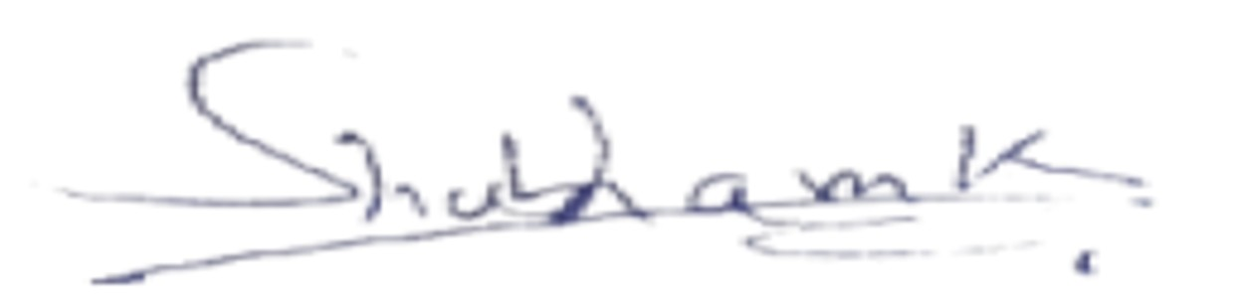

Signature of Faculty

Signature of Student

**(Prof. Shubham Kumbhar)** **(Mr. Om M. Gohil)**

Date:

Place: Mumbai

Contents

Acknowledgement

Declaration

Certificate

Abstract

INTRODUCTION

What Happened (2012)

The Second Chance (2012)

What Happened Part 1(2013)

What Happened Part 2(2013)

What Happened Part 1(2014)

What Happened Liber Primus (2014)

Cicada 2016

PGP Signed Messagev (April 2017)

Liber Primus Solved Pages

BIBLIOGRAPHY

**Introduction**

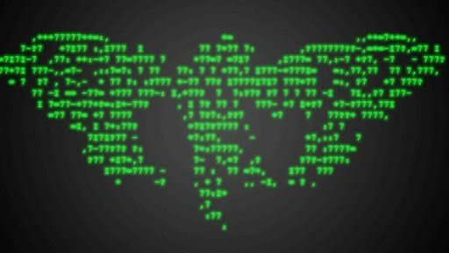

Cicada 3301 is an enigmatic organization that first appeared on the internet in January 2012. The group is known for creating complex puzzles and cryptographic challenges that are used to recruit highly intelligent individuals for unknown purposes. The identity, motives, and objectives of the group remain a mystery. "Cicada 3301 is a mysterious online puzzle game that has been captivating the internet since its inception in 2012. The group behind Cicada 3301 is unknown, and the puzzles they release are incredibly difficult to solve. However, over the years, a dedicated group of individuals have been able to solve some of the puzzles, leading to fascinating discoveries and theories about the group's intentions.

They were subsequently invited to join a private online forum, where they were given additional puzzles to solve. The group eventually disbanded due to disagreements, but their story highlights the allure and mystery surrounding Cicada 3301. The puzzles associated with Cicada 3301 typically involve cryptography, steganography, data analysis, and other related fields. In some cases, the puzzles have required participants to use specific software or hardware tools to solve them.

The puzzles often involve references to various obscure books, art, music, and other cultural artifacts. Some of these references have been linked to occultism, secret societies, and other esoteric subjects

The Cicada 3301 puzzles have inspired a number of copycat puzzles and alternate reality games (ARGs) over the years. Some of these puzzles have been created by the original Cicada 3301 organizers, while others have been created by independent individuals or groups.

Cicada 3301 has gained a cult-like following among codebreakers, cryptographers, and amateur detectives. The puzzles have been featured in several books, documentaries, and online forums, and have inspired numerous imitations and copycats.

Some of the clues and puzzles related to Cicada 3301 have included references to various philosophical and mystical concepts, including Kabbalah, Buddhism, and the writings of Aleister Crowley

In addition to the online puzzles, Cicada 3301 has also used physical clues, such as posters and QR codes, to lead solvers to the next stage of the challenge.In addition to the puzzles themselves, Cicada 3301 has also spawned a subculture of fans and enthusiasts who are fascinated by the mystery and secrecy surrounding the organization. Some of these fans have formed online communities and forums dedicated to solving the puzzles and discussing their theories about Cicada 3301's true purpose

Person who claimed to solve the puzzle

* Liberate Hong Kong

One person who has been linked to Cicada 3301 is known as "Liberate Hong Kong", who claimed to have received a message from Cicada 3301 and shared it on social media. Some individuals have claimed that the messages shared by "Liberate Hong Kong" contained warnings about a global conspiracy, and urged others to take action to prevent the spread of misinformation and the erosion of civil liberties. Others have suggested that the messages contained coded instructions for carrying out a specific task or mission. However, without verifiable evidence, it is impossible to say with certainty what the content of these messages may have been or what their true purpose might have been. As with many aspects of Cicada 3301's activities, there is a great deal of speculation and uncertainty surrounding the messages shared by "Liberate Hong Kong".

* Marcus Warnner

And Virginia Tech rising sophomore Marcus Wanner German computer scientist solved it—in 2012, when he was a home-schooled 15-year-old in Copper Hill, Virginia. The exercise, which first appeared on the underground website 4Chan, was created by a secretive group that identified itself as Cicada 3301.Marcus Wanner is an Australian cryptographer who claimed to have solved the 2014 Cicada 3301 puzzle. According to reports, Wanner was able to decipher the message contained within the 2014 Cicada 3301 puzzle, which led him on a journey that spanned several continents. Wanner’s journey reportedly took him to various locations around the world, including Malaysia, Poland, and France. Along the way, he allegedly met with other individuals who were also attempting to solve the Cicada 3301 puzzle.

* Joel Eriksson

Joel Eriksson is a Swedish programmer who claimed to have solved the 2012 Cicada 3301 puzzle. Eriksson's solution to the 2012 Cicada 3301 puzzle involved decoding a message that was hidden within an image, which led to a series of increasingly difficult challenges that tested his skills in cryptography, programming, and other areas. Joel Eriksson is one of the few known people to have actually solved it since the first challenge appeared online. “I stumbled upon it on one of the image boards the first image was posted to in 2012,” says Eriksson, a 34-year-old cryptosecurity researcher and developer from Sweden.

Eriksson's solution to the puzzle involved a complex combination of computer programming, cryptography, and other skills. He has not revealed the details of his solution to the puzzle, and it remains a mystery to this day.Eriksson's claim to have solved the Cicada 3301 puzzle has been met with some skepticism, as there is no way to independently verify his solution

* Rafael Rosa

Rafael Rosa is a software developer from Brazil who gained notoriety in the Cicada 3301 community for his claim to have solved a portion of the 2017 puzzle known as the "Liber Primus" or "Book of theFirst".According to Rosa, he used a combination of techniques to decode the cipher and language used in the Liber Primus, including anagrams, binary code, and steganography. Rosa claimed that he was able to translate the text in the book into Portuguese and that it contained a message from the Cicada 3301 organizers encouraging him to continue his pursuit of knowledge.

* Craig Bauer

Craig Bauer is a professor of mathematics and computer science at York College in Pennsylvania, USA. While he is not Australian, he is known for his work in cryptography and has published several books on the subject.Bauer became interested in the Cicada 3301 puzzles and began working on them in his spare time. In 2015, he published a book called "Unsolved!", which includes a chapter on the Cicada 3301 puzzles and his attempts to solve them.In 2017, Bauer claimed to have successfully solved the 2014 Cicada 3301 puzzle. According to Bauer, the solution involved a complex series of cryptographic keys and hidden messages that led to a website where the final puzzle was posted.Some of the more notable individuals who have been associated with Cicada 3301 include computer scientist and privacy activist Jacob Appelbaum, who was named in a 2014 Rolling Stone article as a possible member of the group.

*Is Cicada 3301 still going on?*

In six years, only two of its 58 pages have been decoded. And 3301 has vanished once more. Their very last message, three years ago, simply served to disown the copycats and scammers who had emerged in their absence and were trying to profit financially from fans' desire for answers.

*Here are the puzzles that have been solved until now*:

Puzzle 1: This puzzle involved an image of a cicada and a message that stated "Hello. We are looking for highly intelligent individuals. To find them, we have devised a test." This led to a series of cryptographic challenges that were eventually solved by a group of individuals who worked together to crack the code. The first puzzle, launched on January 4, 2012, was solved on January 5, 2012. It involved an image that contained a message hidden in steganography, a book cipher, and a reference to the Liber AL vel Legis, a holy book of Thelema, a religious philosophy founded by Aleister Crowley.

Puzzle 2: This puzzle involved a book cipher that used pages from a book to create a message. The solution to this puzzle led to an image that contained a hidden message. The second puzzle, launched on January 5, 2013, was solved on January 6, 2013. It involved an image that contained a message hidden in a visual cipher, a QR code, and a reference to the book "Liber AL vel Legis". In 2013, a group of three friends known as "Liber Primus" successfully solved the second Cicada 3301 puzzle, which led them to a real-life location in Hawaii. The trio then received a book called "Liber AL vel Legis" with a note that read, "We want to recruit people who are smart and can think outside the box."

Puzzle 3: This puzzle involved a music file that contained a spectrogram image that led to an image of a cicada and a message. The solution to this puzzle led to a website that contained another challenge. The third puzzle, launched on January 5, 2014, was partially solved in February 2014. It involved an image that contained a message hidden in a book cipher and a reference to the book "Liber AL vel Legis". The 2014 puzzle contained references to William Gibson's novel "Neuromancer" and the philosopher Ludwig Wittgenstein. Understanding these references and being well-read in these areas is often key to solving the puzzles, which adds another layer of complexity to the recruitment process

Puzzle 4: This puzzle involved a series of images that contained hidden messages. The solution to this puzzle led to a book that contained a message. The fourth puzzle, launched on January 4, 2016, has not been fully solved yet. It involved a music track that contained a message hidden in a spectrogram, a visual puzzle, and a reference to the book "Liber AL vel Legis". The 2016 puzzle, which was different from the previous ones and included a video message Professor Jason Polakis

Puzzle 5: The most recent puzzle released by Cicada 3301 was in 2017. The puzzle consisted of a series of clues and codes posted on various websites and forums, and it was widely discussed and attempted by codebreakers and puzzle enthusiasts around the world. However, despite significant effort and collaboration, the puzzle remains unsolved to this day. The 2017 puzzle released by Cicada 3301 was known as "Liber Primus".

The 2017 Cicada 3301 puzzle involved a series of clues and codes that were posted on various online platforms, including Twitter, Reddit, and a hidden image on an onion site. The clues included references to historical figures, literature, and music, and required a deep understanding of cryptography and steganography to decipher. The puzzle also featured a unique twist in the form of a physical challenge. One of the clues led to a location in the United States where a small metal sculpture was hidden. The sculpture contained a code that was required to progress further in the puzzle, adding an extra layer of complexity and intrigue to the already challenging puzzle.

The puzzle was particularly notable for its use of a new encryption method called "polyalphabetic substitution with numbers." This encryption method was unlike anything seen in previous Cicada 3301 puzzles, and it stumped even some of the most skilled codebreakers and cryptographers. The puzzle required participants to decipher the meaning of the symbols and codes in order to unlock further clues and instructions

The book was written in an unknown language, and the puzzle required participants to decipher the meaning of the symbols and codes in order to unlock further clues and instructions. Some of the techniques used in the book included complex cryptography, steganography, and esoteric symbolism The first few pages of the book included a table of contents, an introduction, and a warning that the text was not for the uninitiated.

Many of the pages were filled with hand-drawn images and intricate patterns that appeared to have hidden meaning. Some of the coded messages were in ASCII art format, while others used complex ciphers such as the Caesar cipher and the Vigenère cipher..

*Some of the cryptic symbols and coded messages found in the book include:*

* Various ciphers, such as the Caesar cipher, the Atbash cipher, and the Vigenère cipher
* Hidden messages within images using steganography
* References to occult and esoteric concepts, including alchemy, Kabbalah, and Hermeticism
* Instructions for performing rituals and meditations, such as the "Dreamachine" and "Mirror Gazing"

*Some of the cryptic symbols and coded messages in the book include:*

* A series of "runes", or ancient symbols used in various cultures throughout history
* A series of "nulls", or empty spaces that may contain hidden messages or patterns
* A series of "keys", or instructions on how to decode the text using various techniques, such as cryptography or steganography
* A series of "pages", or sections of the book that contain additional clues or instructions

# What Happened (2012)

## **The Start**

On January 4th, users browsing 4chan's /x/ board were greeted with a mysterious image, unlike much else really seen on that board. It displayed the following message in simple, white-on-black font:

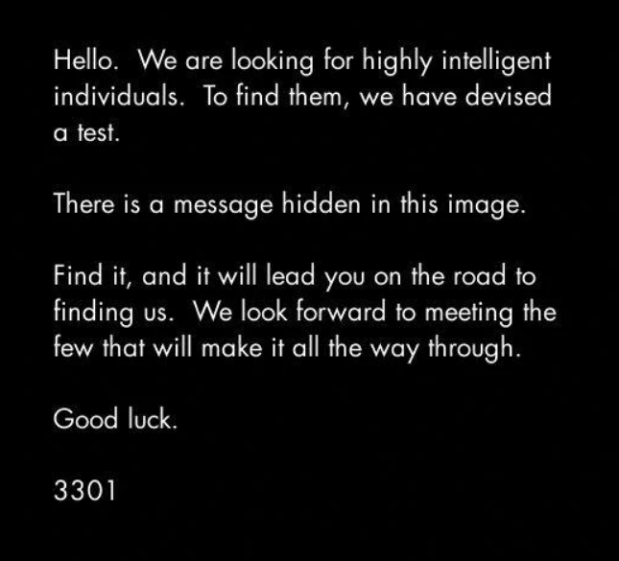

There was indeed a message hidden in this image

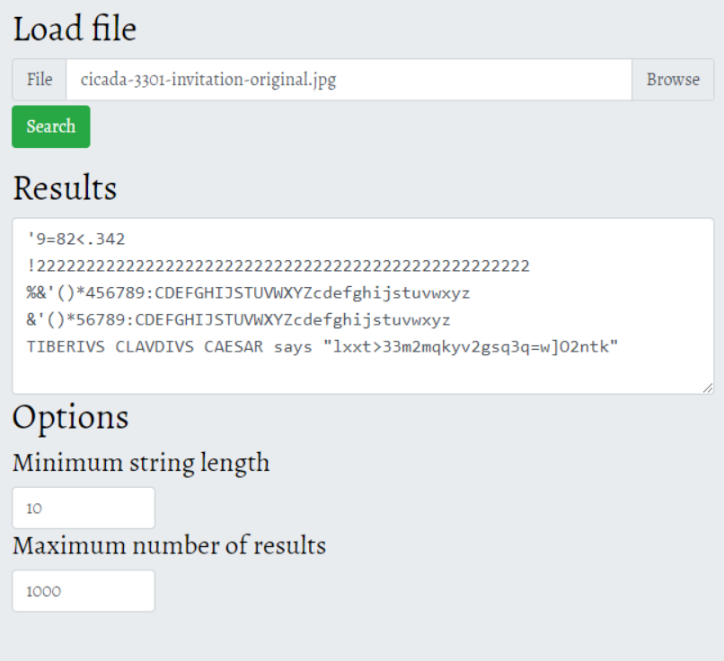

The text about TIBERIVS CLAVDIVS CAESAR indicates that the following text is a Caesar Cipher. You can use [Boxentriq's Caesar Cipher decoder](https://www.boxentriq.com/code-breaking/caesar-cipher) to solve it:

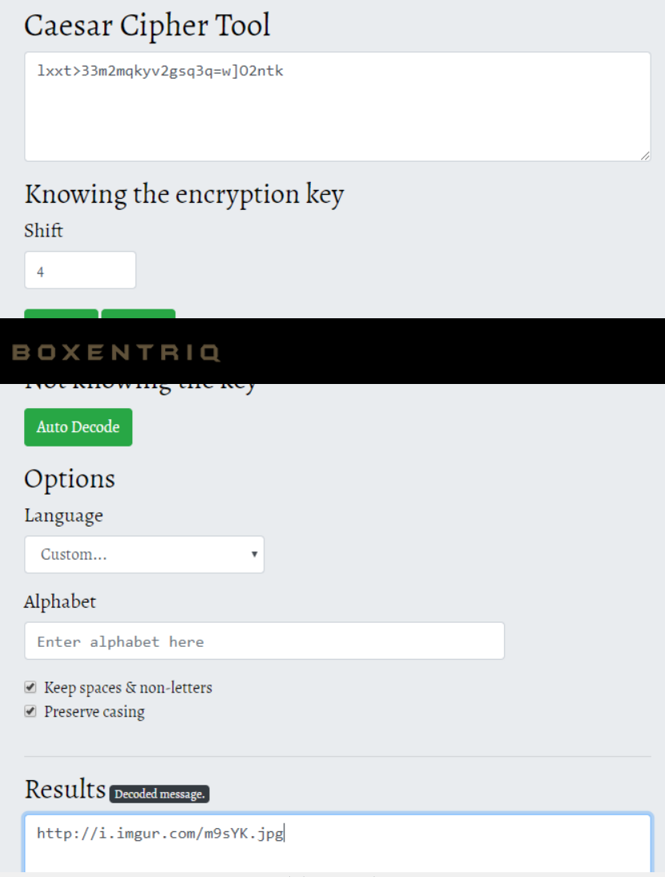

To decode it, you will have to set the Shift to 4 and the Language to "Custom". It will then give a link to an Imgur image: <https://i.imgur.com/m9sYK.jpg>. This image however looks like a dead end

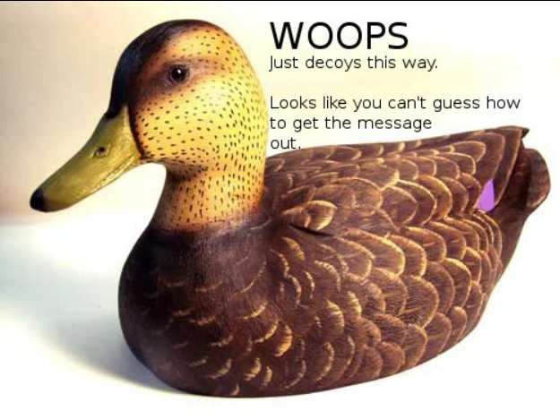

This was a difficult clue to follow, but solvers soon realized that it meant that the program OutGuess had to be used (hence the words guess and out).Outguess is a steganography program designed to hide messages within images.

*The Message*

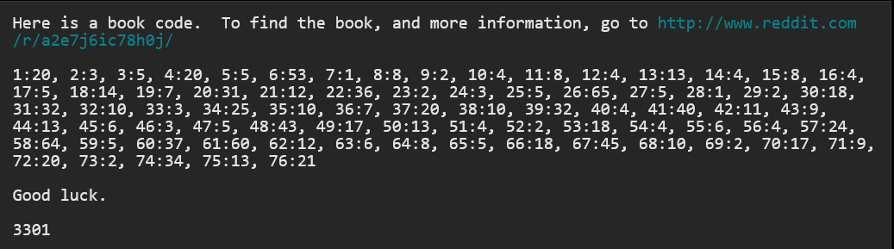

*The Subreddit Code*

The subreddit contained several text posts and two images, [Welcome](https://old.reddit.com/r/a2e7j6ic78h0j/comments/o3hoi/welcome/) and [Problems?](https://old.reddit.com/r/a2e7j6ic78h0j/comments/o6n9a/problems/) While the *Problems?* post was created by the user Reddit u/ImagoOnNib, all others posts were created by u/CageThrottleUs.

At first, only a handful of posts and the "Welcome" image were available. As time when on, more posts regularly appeared and the "Problems?" image was posted.



Each image contained an OutGuess message. Welcome's was this:

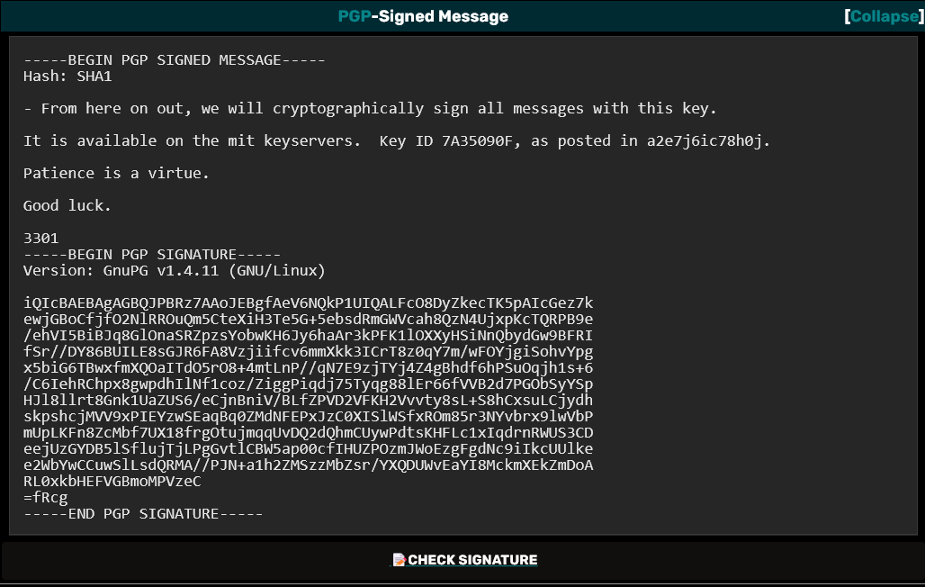

This is VERY important information, since there are many imposters pretending to be Cicada 3301. This PGP (GnuPG) key is how to verify their authenticity. Only real messages from Cicada 3301 are signed with this key ID: 7A35090F. Using this ID, their public key can be downloaded from the MIT key server.

*King Arthur references*

The second image on the Subreddit looked like this:

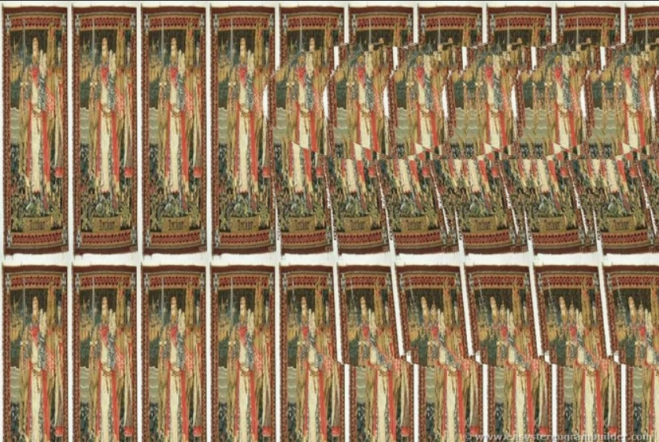

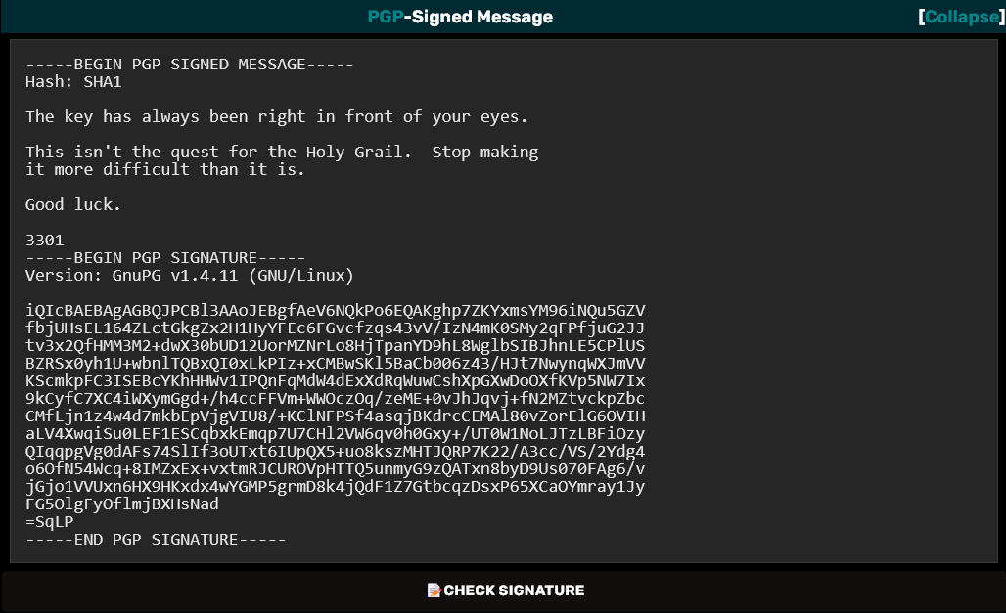

As expected, it is PGP-signed. The image depicts a repeating pattern of an "King Arthur" tapestry. Furthermore, trained eyes can see a cup hidden with a [autostereogram](https://en.wikipedia.org/wiki/Autostereogram) - given the Arthurian context, it represents the Holy Grail.

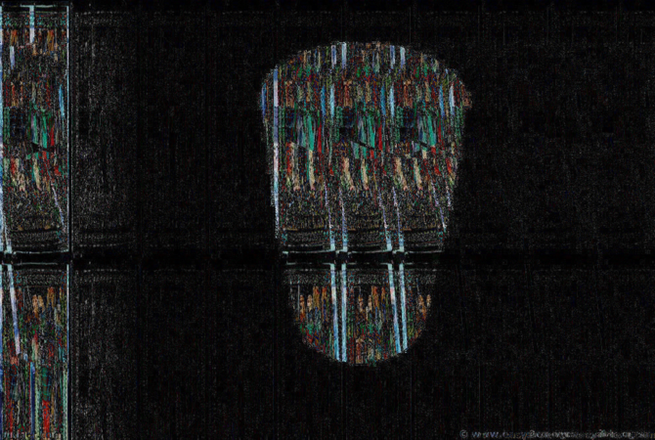

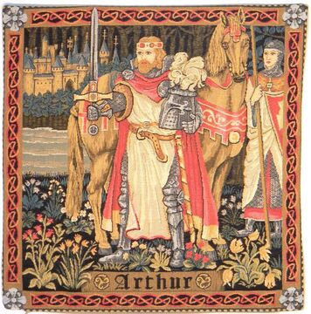

*Solving the code*

On the subreddit header image, a sequence [Mayan numerals](https://en.wikipedia.org/wiki/Maya_numerals) can be read. Their Arabic counterparts are: 10 2 14 7 19 6 18 12 7 8 17 0 19

Solvers noticed that the subreddit title, a2e7j6ic78h0j, could be converted to the above sequence by replacing each letter with their position in the alphabet starting with A as 10. Numbers could simply by left as is.

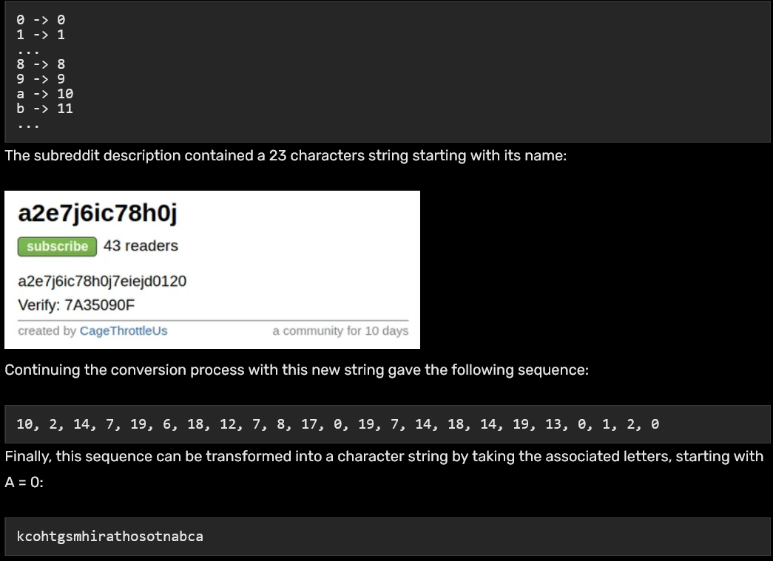

The text lines were found to be a [Vigenère cipher](https://www.boxentriq.com/code-breaking/vigenere-cipher). The numbers can be translated to a Vigenère key by letting 0 = A, 1 = B, etc. You can do this using [Boxentriq's letters to numbers](https://www.boxentriq.com/code-breaking/letters-to-numbers) tool, which gives you the key kcohtgsmhirathosotnabca.

Now you can decode the texts, line by line, using [Boxentriq's Vigenère cipher](https://www.boxentriq.com/code-breaking/vigenere-cipher) tool.

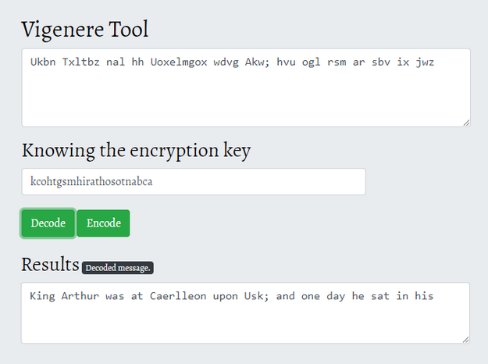

This text is from Thomas Bulfinch's Mythology, a classic work based on the Mabinogion tales about King Arthur and the knights of the round table, and their hunt for the holy grail. This is the [original text](https://www.bartleby.com/182/202.html).

Using this text, you can now decode the book cipher using [Boxentriq's Book Cipher](https://www.boxentriq.com/code-breaking/book-cipher) tool:

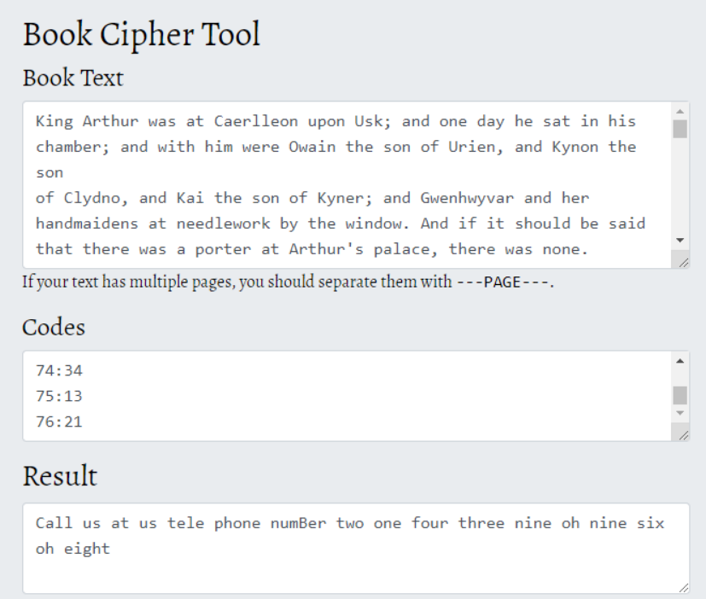

What confused many solvers a bit were that the text containted double spaces in some places. It was easy to miss the double spaces if you copy-pasted the text from the subreddit, which resulted in getting some characters wrong from the book cipher. Some therefore believed that full stops (.) should be filtered out, which you shouldn't do.

*The Phone Number*

Having retrieved the source text, the book code mentioned in the Outguessed message of the initial image could be applied. In a book code, each letter is encoded with two numbers: a line number and a character index in the line. Applying the book code to the text with the full stops removed gave the following string of text:

***Call us at us tele phone numBer two one four three nine oh nine six oh eight***

This was a telephone number, specifically (214) 390-9608. This number has since deactivated. Calling this number gave the following message:



Looking at the image posted on 4chan, it had no obvious prime numbers, but the size is 509 x 503 pixels. It happens that both 509 and 503 are prime numbers. Therefore the total number is 509 x 503 x 3301 = 845145127

*The Website*

Going to this website led to an image of a cicada and a countdown.

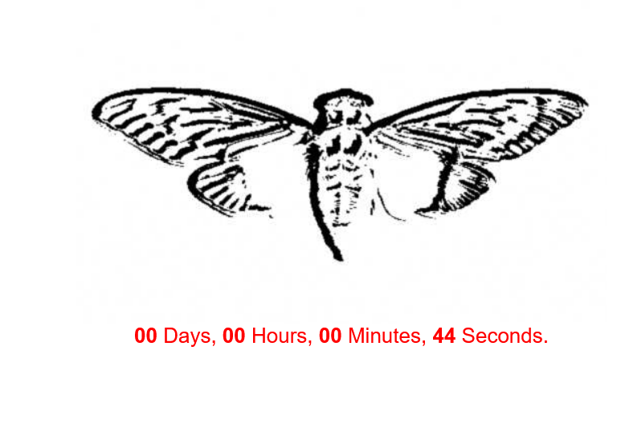

Using OutGuess on the image produced the following message:

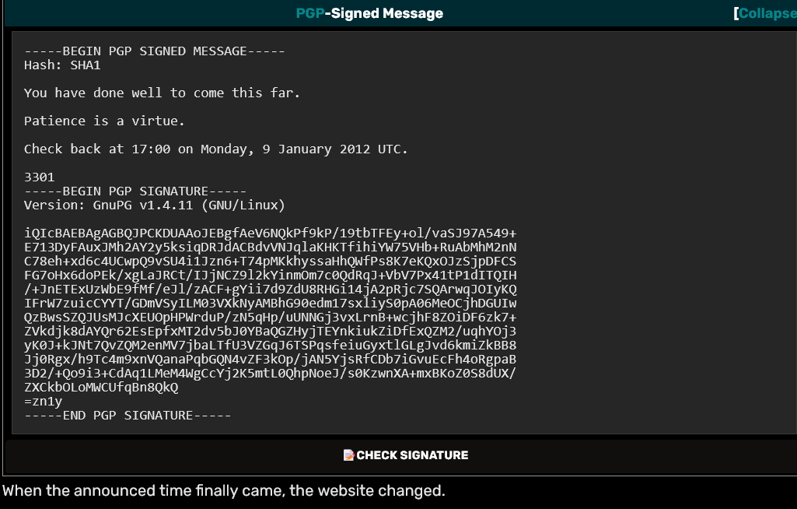

*The Global QR Codes*

*The updated website gave a list of coordinates, with seemingly the same cicada image.   
Archive:* [*https://cicada-solvers.github.io/845145127.com/coordinates/*](https://cicada-solvers.github.io/845145127.com/coordinates/)

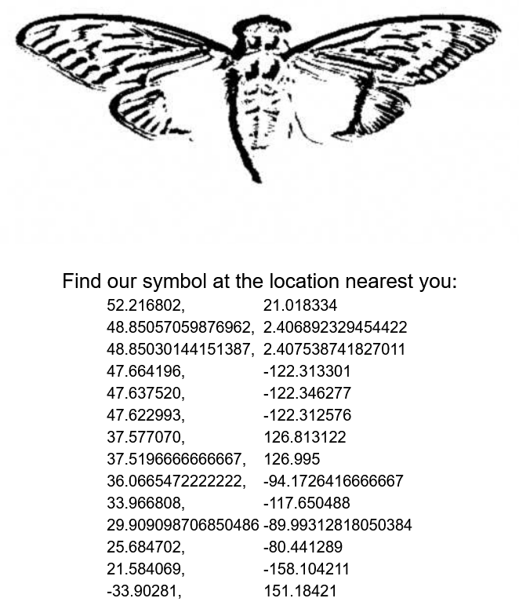

However, applying OutGuess on the cicada image produced a different message, containing coordinates. They were the same as what could be found on 845145127.com excepted for two missing coordinates

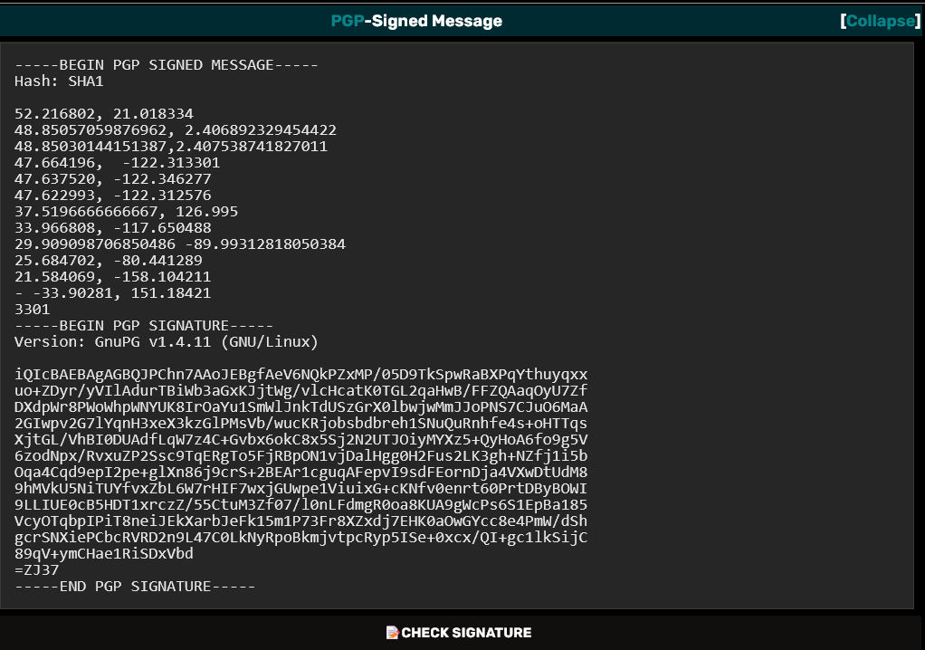

The location were spread out over the world in California, Australia, Hawaii, South Korea, Poland, and other places. Visiting these exact locations there were real posters with an image of a cicada and a QR-code

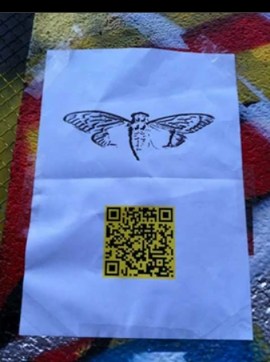 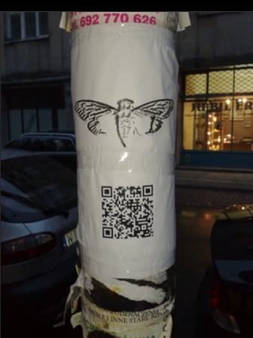

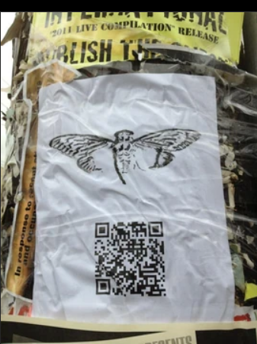 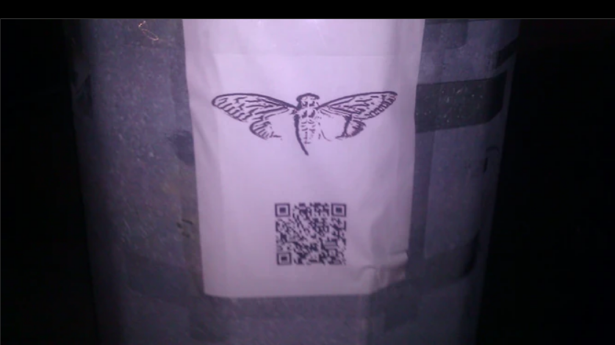

At this point the community realized 3301 could potentially be a global organization of some very talented people, not just a single skilled 4chan user.

Puzzlers collaborated to visit the locations and take photos. They found there were two variants of posters, containing QR codes. They contained new book ciphers, as well as a warning not to share too much.

*First message:*

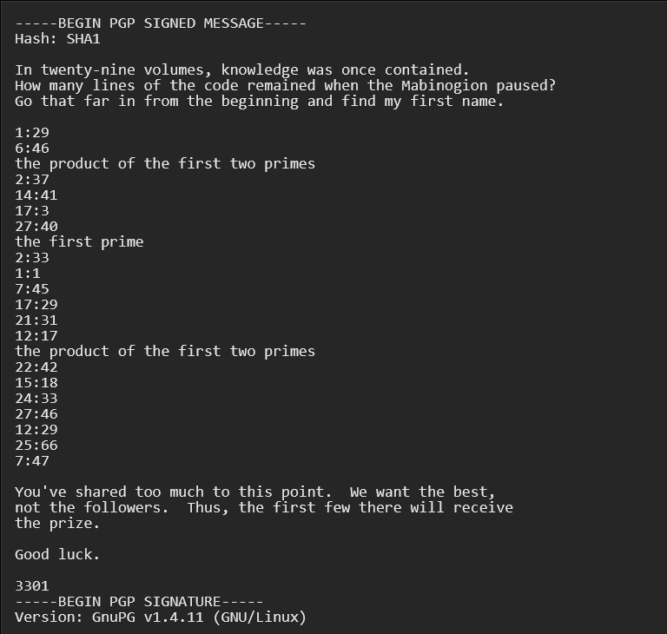

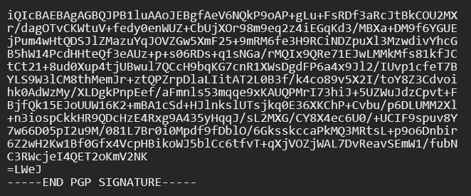

*Second message:*

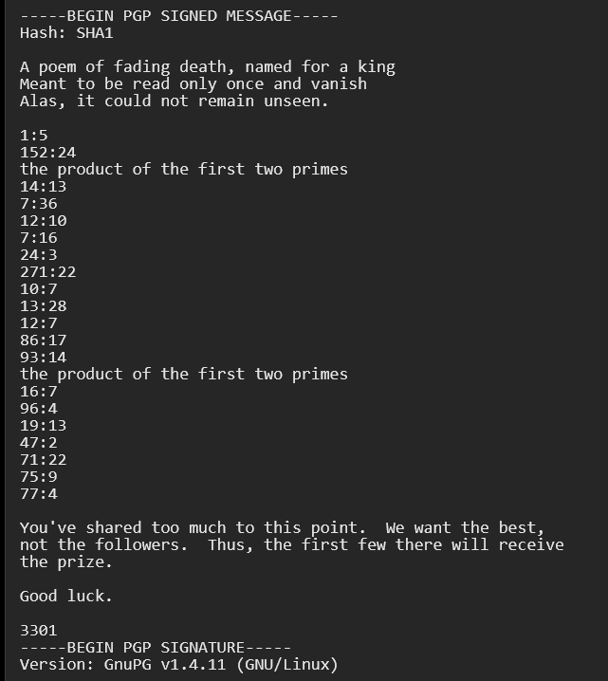

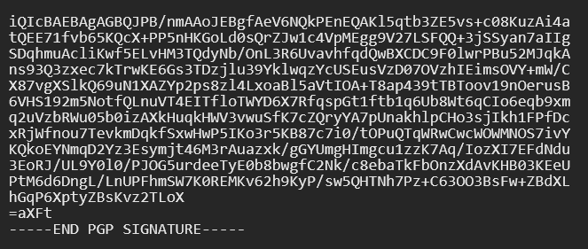

Solvers knew these were book codes along with a description of the book needed. A warning about too much collaboration was also included, saying that only the first few, or the active few, that make it to the end will receive entry.

*Agrippa*

A poem of fading death, named for a king  
Meant to be read only once and vanish  
Alas, it could not remain unseen.

By typing in keywords from its description, solvers were led to the poem [Agrippa](https://web.archive.org/web/20120131164229/http:/www.williamgibsonbooks.com/source/agrippa.asp). Applying the book code (and interpreting literally *the product of the first two primes*) produced

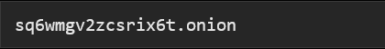

Later, also the first book was found. It was Encyclopaedia Britannica, 11th Edition, Volume 6, Slice 3 "Chitral" to "Cincinnati"

*Into The Dark*

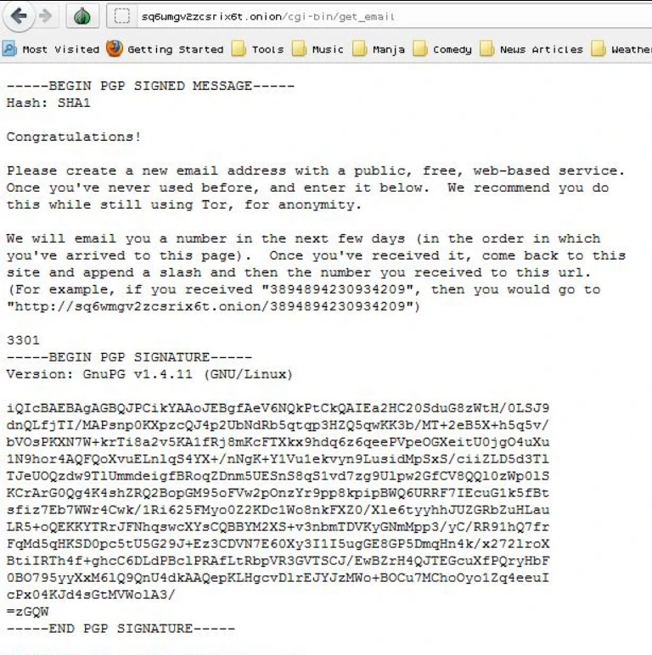If you are familiar with the dark web, you will recognize that this is an address on the TOR network. The dark web is a kind of "internet underground", which requires specific software and configurations to access. Identities and locations stay anonymous, and cannot be tracked. This is where the puzzle went "off the grid".

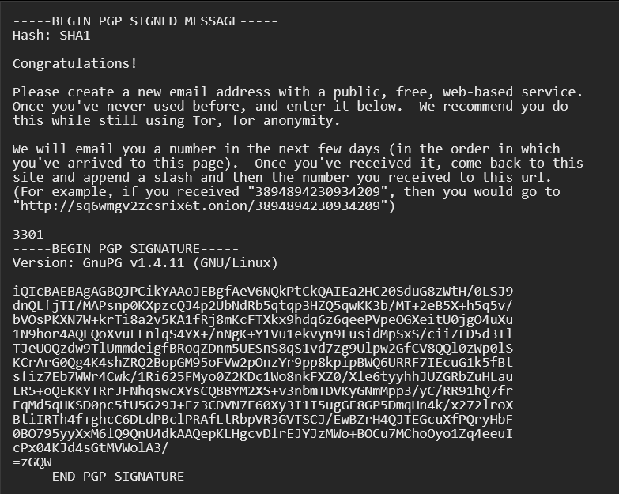

*The RSA Emails*

Those who applied early enough were greeted with an email giving them a number. Following 3301's instructions, they went to "sq6wmgv2zcsrix6t.onion/NUMBER". A similar message to this one appeared:

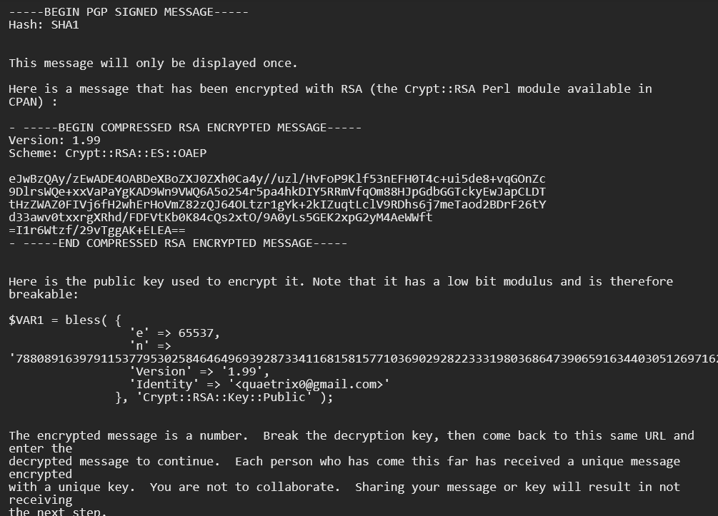

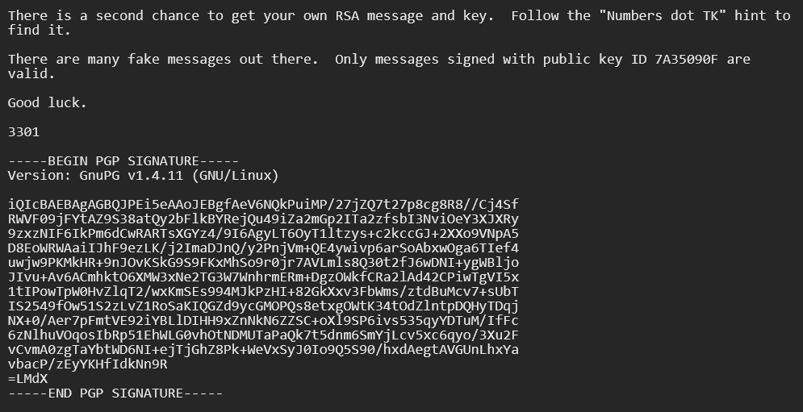

Everyone received a different 'n' value and a different RSA encrypted message. Of course, the "Identity" field would also be different. A mention of the *"Numbers dot TK" hint* made people that didn't receive an email aware — presumably through leaks — of the existence of a second chance. Around the same time, the 845145127.com website changed

Regarding publicly shared keys or messages, their owner would be emailed the following message by 3301:

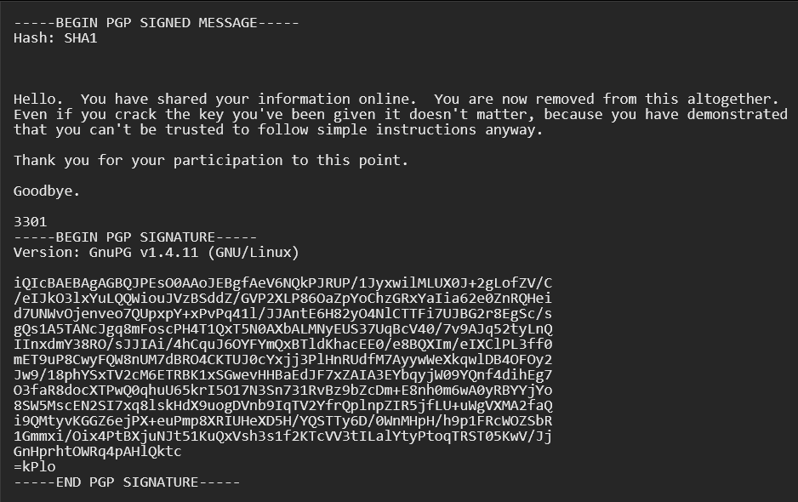

The RSA puzzle

To crack the RSA encryption, people had to factor their n — the modulus — into its two prime factors. In general, this factorization is too computationally expensive, but the modulus being small made it possible (*it has a low bit modulus and is therefore breakable*). Decrypting the message could then be possible using a [simple perl script](http://codepad.org/nBIS91M4).

For the above message, n factors into **80411114232571782218163489375797613948878398942588985417 and 98007492061325958997349177934627388613835953553459586261**. To determine these factors, solvers had to use tools such as *factmsieve*, letting them run for a few hours. The decrypted message is



Submitting the correct answer to the same onion initially resulted in a 500 error, however on the 17th January at around 2:49 UTC, it instead reported

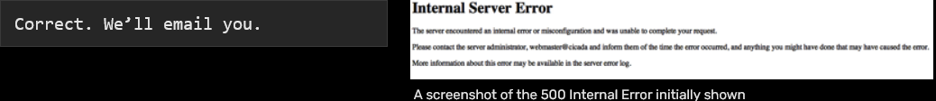

The MIDI puzzle

As promised, 3301 sent an email telling people to go backtheir'sq6wmgv2zcsrix6t.onion/NUMBER' page. The page now had a message unique to each participant.

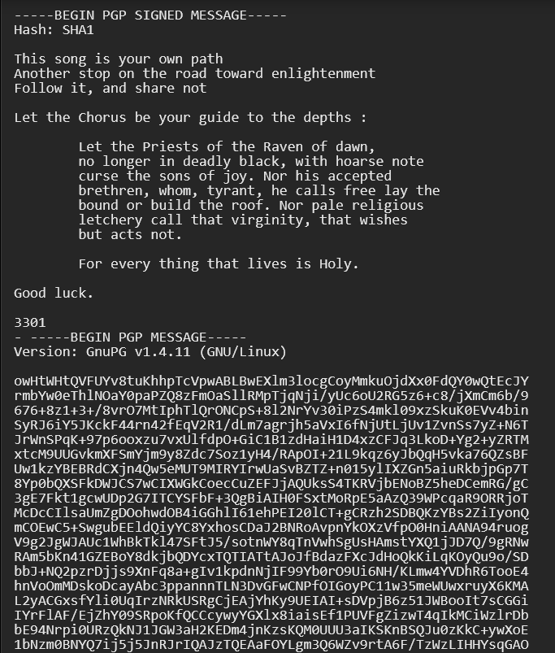

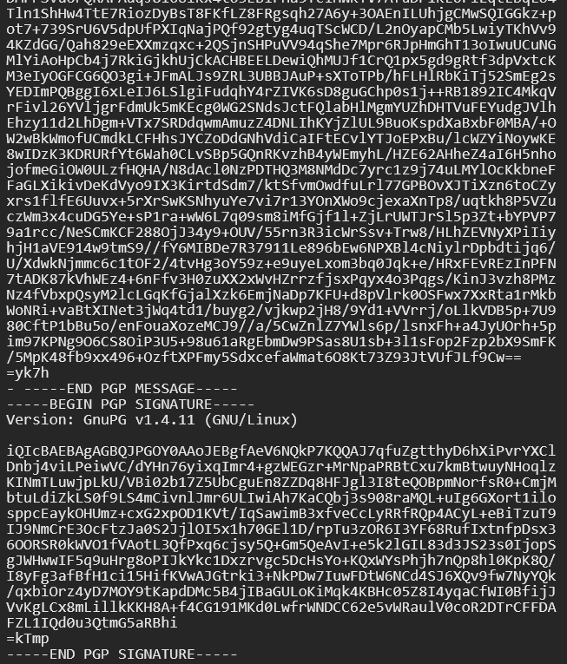

The large 'PGP MESSAGE' block differed in each message. It is a PGP-signed binary file named 'Cicada.mid'. To extract it, the message must in the first place be isolated and the leading "- " on the armor headers should be removed. The file is then decrypted using:



The resulting file is a MIDI music [file](https://github.com/ctvrty-rozmer/bruh/blob/master/song.mid). It contains of two songs, but neither of them sound to be real music pieces. The poem included in the PGP-signed message is the "Chorus" from William Blake's poem [*A Song of Liberty*](https://en.wikisource.org/wiki/Page:The_Marriage_of_Heaven_and_Hell_-_copy_D.djvu/27)

It was noticed the second music track encodes the poem. A MIDI file describes the presses/releases of instruments keys; thus, each tone played has a defined note (encoded as a number) and a duration. Each *(note, duration)* pair played could then be associated with a letter given by the poem:

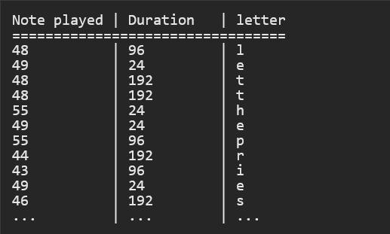

In short, the second MIDI song was a substitution cipher where each note played corresponded to one letter. Once the full substitution table has been created, the rest of this second song can be decrypted. It simply repeated the Chorus two more times.

Following 3301's hint (*Let the Chorus be your guide*), the same substitution table was tried on the first track. Unfortunately, this resulted in a failure as almost no notes were in common. Using frequencies analysis on the *(note, durations)* pairs, or by noticing that early letters in the alphabet were associated with shorter durations, a new substitution table can be crafted. Alternatively, this is equivalent to shifting up all notes in the previous substitution table by an octave (which equates to an addition of 12). This could have been hinted by 3301 ("...your guide *to the depths*"), as the second song was lower-pitched. However, 3 characters weren't in the poem: q, x and z. But the substitution table can naturally be completed:

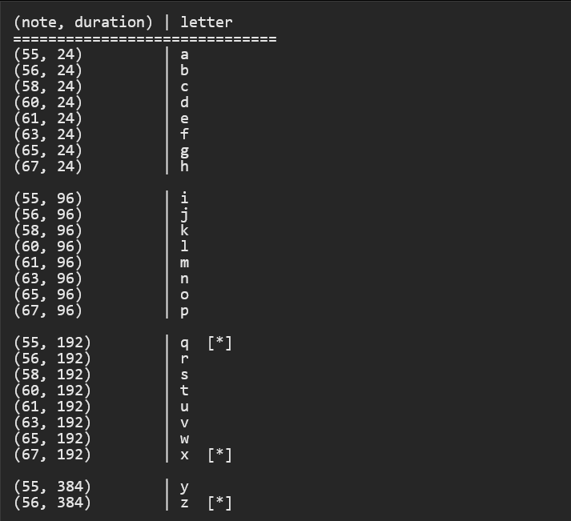

Decrypting the first song results of the above MIDI gives :

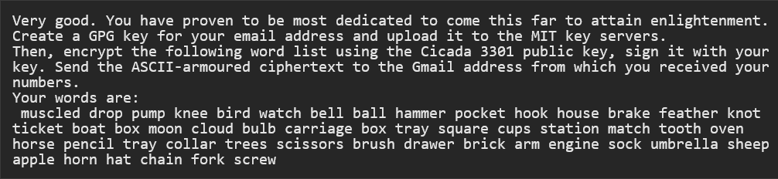

Each MIDI file contained 50 unique words. Running the following commands outputted the PGP-signed message which could then be sent.



*The Invitation*

Those who sent an encrypted PGP signed email with their words received at around Monday, February 6th an email informing them that there would be no more puzzles. It also gave directions to log on to a Tor hidden service, with a given username and password. Around the same time, they were invited with the infamous ["leaked email"](https://uncovering-cicada.fandom.com/wiki/The_Leaked_Email).

From here, nobody knows what really happened, as the original puzzle was not very well documented in its end stages like the second puzzle was. Hopefully one day this will come to light, but after receiving this email every person that did so went completely dark, as if they had disappeared from the internet. Nobody knew how deep the rabbit hole went, but all the solvers could agree

What happened after this is mostly still not known, apart for few slips when some people told a bit more about what was going on later. Logs of those testimonies can be found on [Unfiction.](https://web.archive.org/web/20160411192912/http:/forums.unfiction.com/forums/viewtopic.php?p=990278#990278) Legitimacy of those is not confirmed, it might be just trolling. After all, 3301 might not exist at all

The Final Message

After a whole month without any word from 3301, the following message was posted on the [subreddit from the start](https://old.reddit.com/r/a2e7j6ic78h0j/) (r/a2e7j6ic78h0j), in a post entitled [Valēte!](http://i.imgur.com/vjuNp.jpg) (meaning goodbye, farewell).

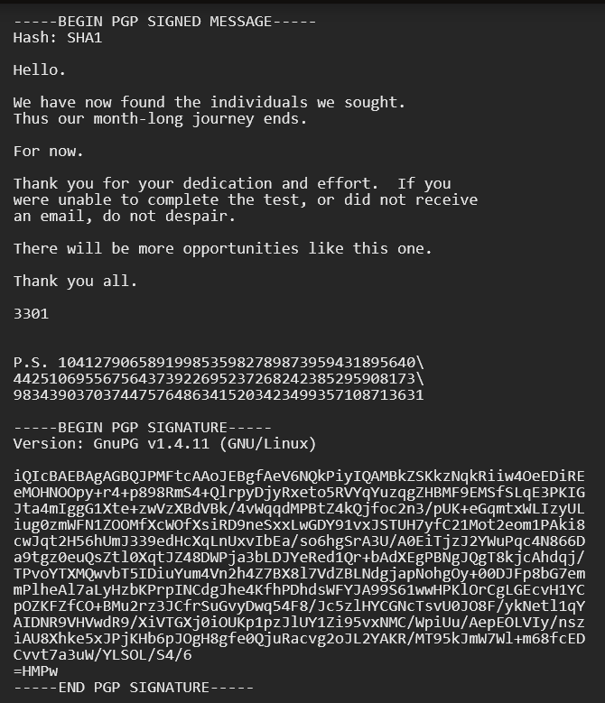

Then nothing was heard from Cicada until January 2013, when their next puzzle started.

# The second chance (2012)

During the [2012 puzzle](https://uncovering-cicada.fandom.com/wiki/What_Happened_(2012)), 3301 offered a second chance for those who did not manage submit an email to the Onion site.

The puzzle authors announced it in a PGP-signed message:

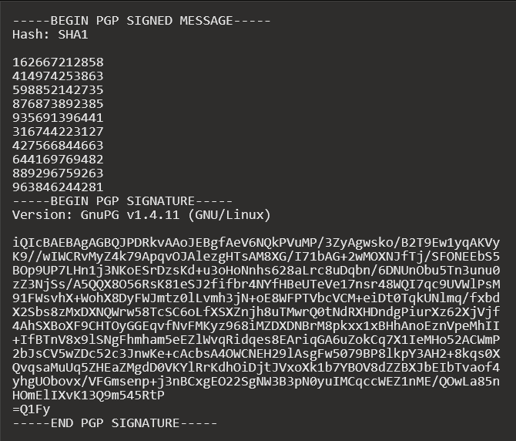

The numbers were found to correspond to image URLs on the website (<http://845145127.com/><number>.jpg), which when OutGuessed, would provide the same messages as the QR codes gained previously from real-world coordinates. This list include the previous known URLs obtained through QR codes.

*Numbers dot TK*

Some time after emails were sent out to participants who put in their emails on the first Onion, a user posted the domain 1853143003544.tk in a chat room on n0v4, although there is no direct indication this website was created by 3301.

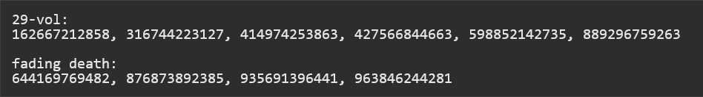

The TXT record for the website said “go to my largest part”. The largest prime factor of the number in the URL was 33091839349, so solvers went to **33091839349.tk.**

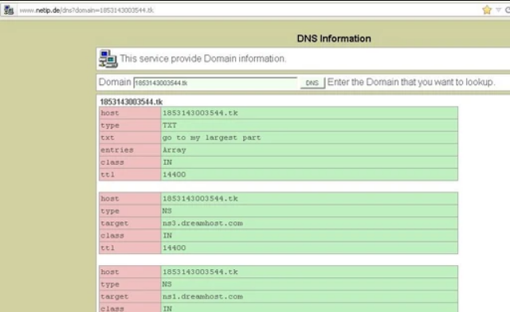

This second website contained another TXT record: “<http://i.imgur.com/NHYLD.jpg>”. It's unclear whether it hosted a webpage, according to some sources[[2]](https://uncovering-cicada.fandom.com/wiki/The_second_chance_(2012)#cite_note-2) it was an HTML page with a black background and the previous picture.

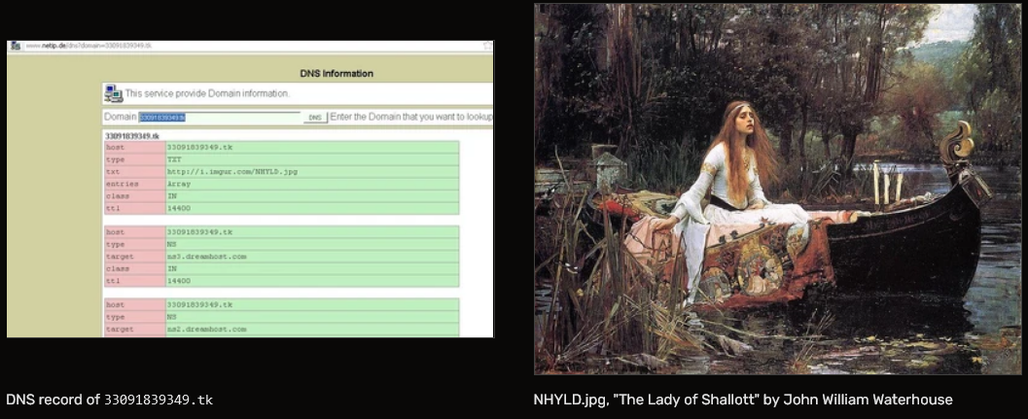

The image, when outguessed, provided the following PGP-verified message from Cicada:

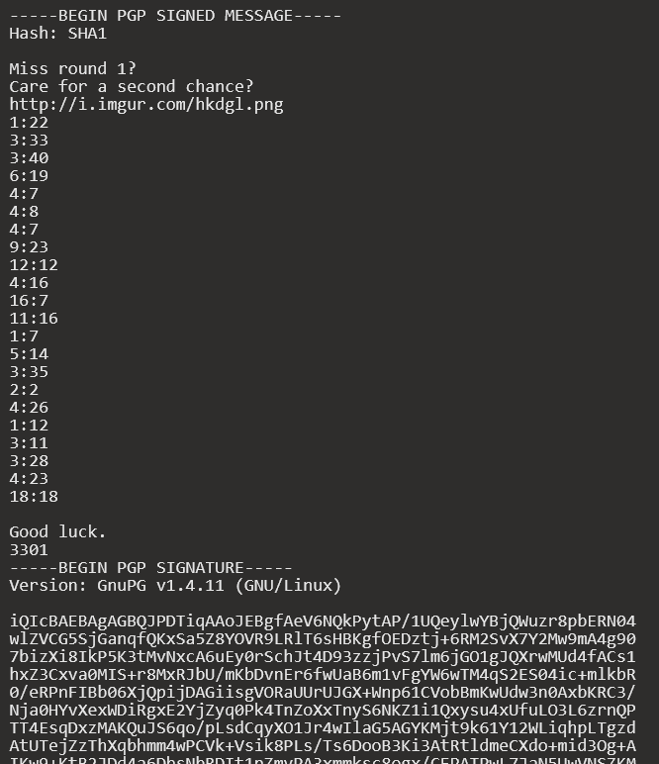

[The image](http://i.imgur.com/hkdgl.png) link referred to in the message is related to William Blake's The Marriage of Heaven and Hell, which is the book used in this book code.

Solving this book code (using [this page](http://www.gailgastfield.com/mhh/mhh.html) as a source) led to another Onion similar to the first one where participants were asked to enter their email addresses: **cginiziglyaobyphonion.**

Users who either submitted their email through either **sq6wmgv2zcsrix6t.onion** (as seen [previously](https://uncovering-cicada.fandom.com/wiki/What_Happened_(2012))) or **cginiziglyaobyph.onion** (from this path) would eventually receive the same RSA-encrypted message.

# What Happened Part 1 (2013)

# *The Invitation*

It had been exactly 366 days since the 2012 Cicada puzzle began. Nothing had happened in 11 months.

Until the 5th of January 2013, when a second image was posted to /x/ and /b/ imageboards on 4chan. There were three threads where 3301 posted [232.jpg](http://static3.wikia.nocookie.net/__cb20130105172757/uncovering-cicada/images/6/67/1357366592898.jpg) on 4chan, two times on /b/ 23 hours apart([1](http://pastebin.com/DDegZqLv),[2](http://pastebin.com/FfKH6ACw)) and once on [/x/](http://pastebin.com/gX0Z5pme).

There was another thread one day earlier, [/b/ thread on 4th](http://pastebin.com/CAZnc0F3) that mentioned "[warning pastebin](https://uncovering-cicada.fandom.com/wiki/The_Infamous_Warning)" and [SMS4TOR (onion.to link)](https://sms4tor3vcr2geip.onion.to/) service.

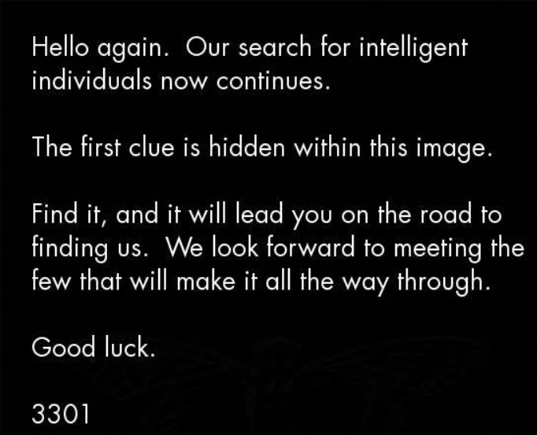

The image was processed by the steganographic tool [*outguess*](https://uncovering-cicada.fandom.com/wiki/OutGuess)*.* This [message](https://uncovering-cicada.fandom.com/wiki/Hidden_content_of_original_image_(January_4th_2013)) was the result. A more analytic look reveals the use of a book cipher. To decrypt the message, one needs to find the text that was used for encrypting.

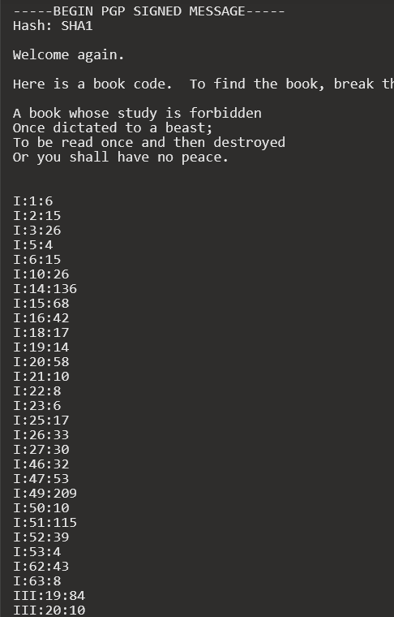

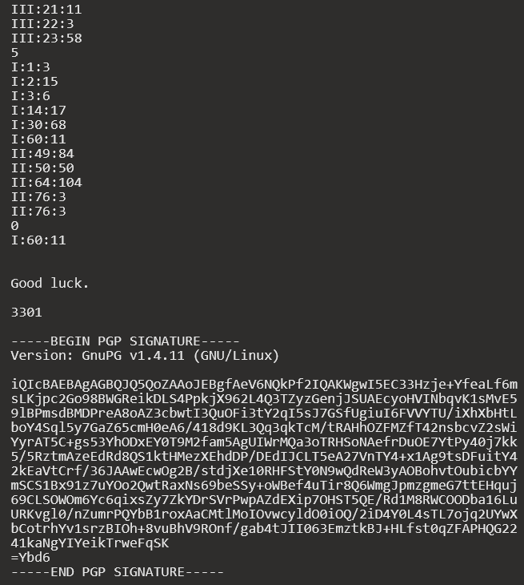

The Law *(Liber AL vel Legis)*

The book that was used to hide the message was *Liber AL vel Legis* by Aleister Crowley. Also known as "[The Book of Law](http://en.wikipedia.org/wiki/The_Book_of_the_Law) ", it is available online, and can be found [here](http://www.sacred-texts.com/oto/engccxx.htm) . The first line *I:1:6* points toward the 6th character of the first line in the first chapter, an 'h' in this case. It was assumed that spaces weren't counted. Punctuation, however, influenced the character chosen for the plaintext. During decrypting, we found that dashes were vital to the process, so we kept them in the plaintext. Using these rules, we encrypted the book cipher and came up with the decrypted message.



The System

The [hyperlink](https://www.dropbox.com/s/r7sgeb5dtmzj14s/3301) ([mirror](https://mega.co.nz/#!N1oXRD5T!I22-ukwhArw1uBV5FCyegCc5Os996rtcKl5sqBKdbrw), [mirror 2](http://www.mediafire.com/download/ui6ov56hu58f4t3/3301.iso)) directed to a dropbox address with a file of 130MB ready for download. After downloading, the file was analysed and a quick check for magic bytes (header bytes) revealed that the offered file was an .iso image

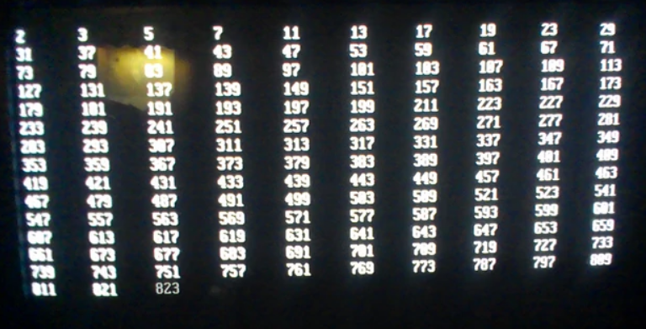

The image file was downloaded by multiple solvers and either burned to disc to run on a computer or opened in a virtual drive. Looking into its contents, we find three directories, "data", "boot" and "audio".

When booting from the image, a boot sequence appeared, printing a sequence of numbers to the screen. Investigating the sequence revealed that the live image prints out all prime numbers up to 3301. There were temporary two-second pauses at 1033 and 3301, where it stops at the latter and moves to the second stage. The next, and last stage of the procedure is a screen that reads:

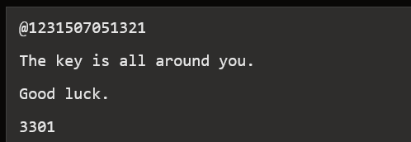

Further analysis of the live image turned up the [routine](https://uncovering-cicada.fandom.com/wiki/Bash_script_from_live_image) responsible for the display of the prime numbers. It is a linux shell script (found [here](http://pastebin.com/sSJgTKQD) , for those interested), which, luckily, is human-readable

Also found in the image was [this](https://uncovering-cicada.fandom.com/wiki/PGP_Signature_from_live_cd) PGP signature, which has been verified to be 3301's official signature released during the puzzle in 2012.

It is possible to interrupt the boot sequence by pressing CTRL+C. User "tc" is active and does not require a password, is in sudoers file with no prompt. `sudo ash` to raise to root.

Another video of Cicada OS: <http://www.youtube.com/watch?v=PTFa6dwCEiA>

*The Music*

The folder "audio" contained an audio recording. The title of the recording was "761.mp3" and can be downloaded [here](https://github.com/rtkd/iddqd/blob/master/2013/02/761.MP3). The ID3 tags show us that the title of the file is "The Instar Emergence" and the artist "3301". The used instrument is a guitar, with distorting effects on it. On the track, a reversed guitar is played and amplified throughout. The song has been deconstructed and checked for hidden reversed messages, but as of yet has turned up nothing out of the ordinary.

The song is in the key of D♭ minor with a custom guitar tuning of D♭-A♭-D♭-G♭-A♭-D♭

[A draft spectral analysis](http://www.anony.ws/i/2013/01/07/SE5OU.png) shows a constant hum at 15.4-16.1kHz, and empty notches under 500Hz starting from 1:56. A hexdump of the mp3 file revealed the following message:

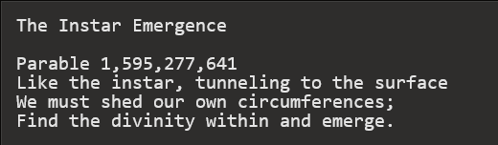

The original message had "\n" attached to the end of each line. This character sequence is used to indicate a new line in some programming languages. These were omitted due to the availability of proper formatting techniques. The subgroup who were assigned the task of analyzing the poem/riddle above have speculated that circumferences might be a reference to perceived limitations rather than actual physical walls. "Find the divinity within and emerge" is most likely a reference to the divine ratio, or phi. Such shedding may also be a reference to the way Cicadas shed their shells.

It has also been pointed out that the song is 2:47 long, or 167 seconds, which is prime. It is also a reversal of the name of the file: 761.mp3, and 761 is also prime.

***The Twitter***

While people still searched through the image to find more hints that may have been overlooked, somebody in the IRC found a [twitter account](https://twitter.com/1231507051321) which got our attention, to say the least. Multiple things were strange about that twitter. It fits the overall "style" of cicada, it was registered shortly after the first downloads of the live image and it had no followers. It was later found to be the reference on the boot CD to @1231507051321 (note: 1231507051321 is a palindromic prime number). The most striking thing about it though was the messages it tweeted. Each tweet consisted of an offset, and 65 bytes of hex code 3301 appears to have used a bot to post the tweets at 5 minute intervals (up until 0:00 GMT Jan 7), then onto four minute intervals until 19:00 GMT Jan 7, where it was seemingly random up until 22:04 GMT Jan 7, where it moved onto two minute intervals. The twitter bot stopped posting tweets at 4:52 GMT on Jan 8. The meaning of the tweets and the rest of the files left the solvers stumped for several hours

***The Gematria***

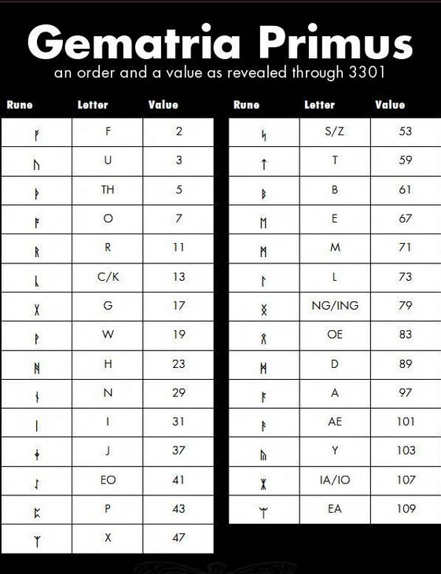

After a day of fruitless searching, an IRC user did the impossible and solved the next puzzle. This user took the 761.mp3 file, and [XORed](https://uncovering-cicada.fandom.com/wiki/XOR) it with the file produced by following the instructions in the twitter. The result was a .jpg file. It was possible to "pre"-construct the image resulting from the tweets.

The .jpg file appears to be a rune table, consisting of three columns, named "Rune", "Letter" and "Value", and 29 entries. "Rune" contains the actual rune character, "Letter" contains one or more plain text characters and "Value" contains a number. It is interesting to note that the numbers to be found in "Value" are all ascending primes, building the sequences of the first 29 prime numbers. As a member in the IRC pointed out, the runes stem from the [Anglo-Saxon rune set](http://en.wikipedia.org/wiki/Anglo-Saxon_runes), and the letters are in the order of the Anglo-Saxon runes. It was revealed that this is a fully-blown Gematria, which can be applied to different pieces of text to reveal interesting numbers. 'The Instar Emergence', for example, produces 761, which is the name of the file and the file's time signature reversed.

It was soon discovered that this image, like the very first one, contained a hidden message, once again masked via OutGuess. The message itself can be found [here](https://uncovering-cicada.fandom.com/wiki/OutGuessed_message_from_rune_table). As in every message from Cicada, the content was followed by a PGP signature, which proved the authenticity of the message

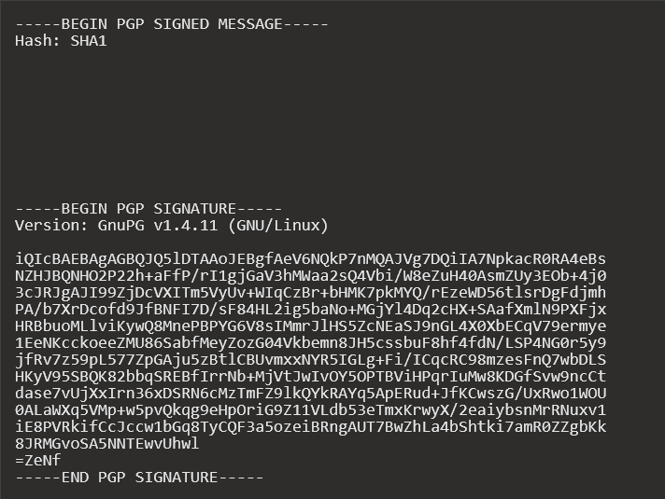

Although this message is from a trusted source, PGP is not capable of verifying the whitespace in the message aside from newlines. PGP messages from untrusted sources may contain modified whitespace but will still produce "Good" verifications.

*The Onion, part 1 of 2*

After finally getting a message from 3301, the solvers found that it was, to quote the IRC, 'Mostly Blank'. The message, it turned out, contained a mixture of tabs and spaces. The solvers converted this to binary, then again to ASCII, then they found the next message:

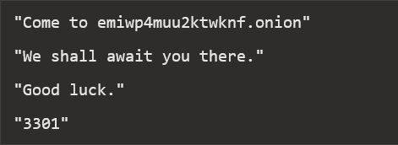

A quick filler: emiwp4muu2ktwknf.onion is a website that can only be accessed through [Tor](https://uncovering-cicada.fandom.com/wiki/Tor), which is using a hidden service URL, similar to the last Cicada puzzle. Upon visiting the website, the solvers were presented with the following message:

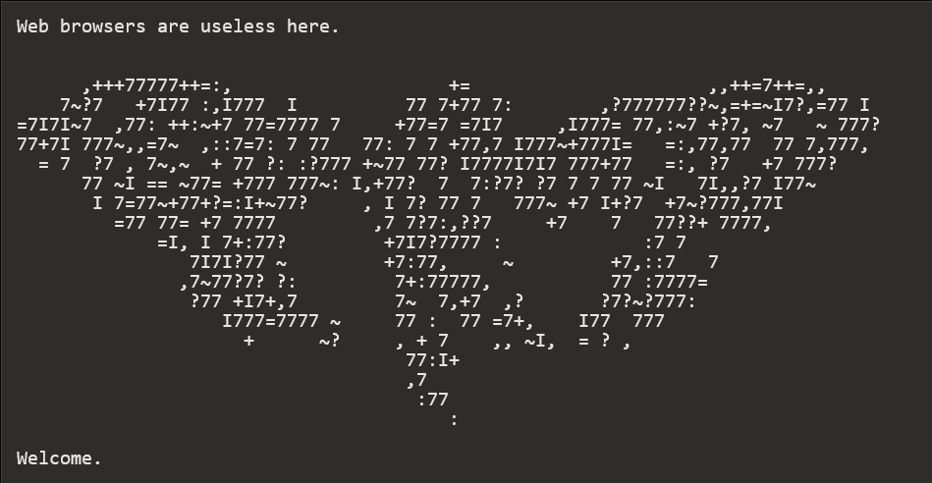

*Establishing a connection*

The solvers soon found that web browsers were indeed useless, and that we would have to telnet into the website through the tor network. Some solvers did so, and they found that the website included an interactive shell. They could type in any number to have it factorized, 'count' to have it count up prime numbers, 'quit' to quit, and 'hello' to return a message It was soon discovered that the messages could be turned into ASCII which created another message, again GPG signed by 3301. The message reads as follows:

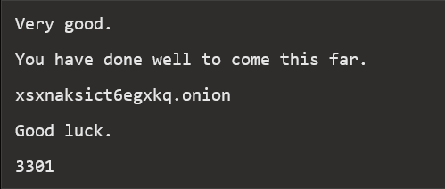

***The Clues***

As the solvers patiently waited for more news about the second .onion, they continued to explore other options that they may have overlooked in the blind rush towards victory. A new message was found by telnetting "hint" or "clue". And XORing result with _560.00 file from the DATA folder on 3301.iso CD image.

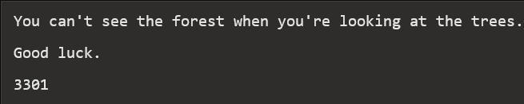

*THE DIFFERENCE*

In Cicada OS the solvers found two files named wisdom and folly in /tmp

<http://codeseekah.com/cicada/folly>

<http://codeseekah.com/cicada/wisdom>  
Wisdom is exactly the same as folly. Neither appear to represent a file type.

*THE PRIMES*

Telnetting 'primes' into the shell printed out a list of primes similar to the one on Cicada OS, but some primes were missing and two have extra spaces in front of them. There were extra spaces between 29-31 and 3257-3259  
And some missing primes between 71-1229

The missing primes are as follows:

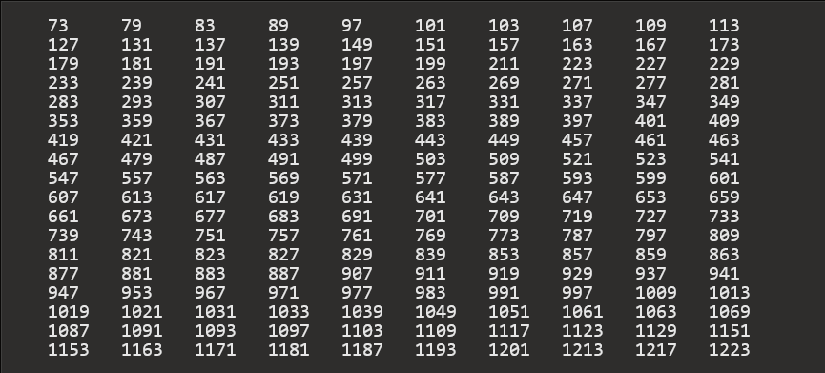

*The Onion, Part 2 of 2*

Once the solvers had found the second.onion, the next logical step was to visit it with a browser. Upon arrival, they found the following:



Rummaging through the source code for the html, they found the following:

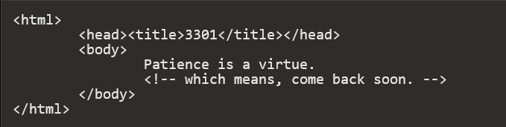

Soon afterwards, someone attempted to telnet into it, producing an error message which contained the address of the VPS on which the site was hosted. Promptly afterwards, the site was taken down. After this the 2nd Onion site finally reopened. The solvers got the following hint:

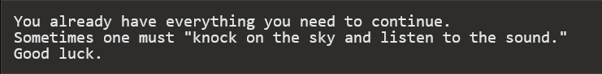

This hint told the solvers that they needed to ping the website's IP address and listen to the reply. Each ping reply was laced with data bytes, which could be combined to make the following:

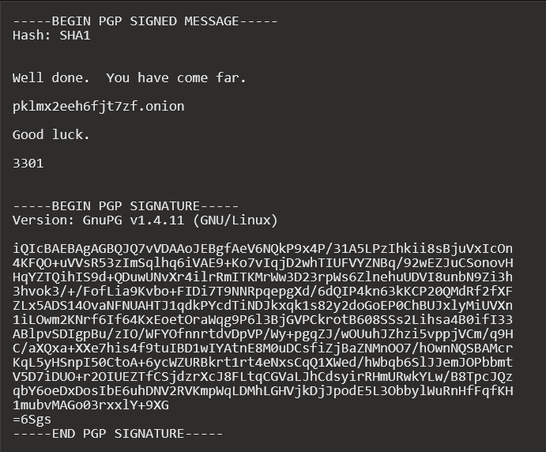

***The Third Onion***

On the third Onion page the solvers recieved a message instructing them to 'standby for coordinates'. They prepared to visit the addresses which these would undoubtedly lead them to. Each poster had a phone number on it as well as an access code. Note that each phone number either ends in 3301 or 1033.

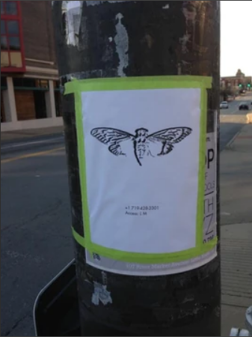

Calling the phone number gave an automated speech asking for a code to be typed into the dialer. Solvers soon realised that they had to convert the access code given in the poster to it's gematrified format and type that in. Upon doing so the following message was given (it varied depending on location, this one was for Portland):

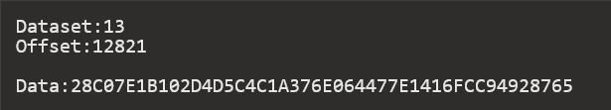

The data, when XORed with the 560.13 (the 13 coming from the dataset) file from DATA, provided the user with a string of text, notably in this case "gbyh7znm6c7ezsmr.onion". It's important to note that each location gave a different onion address. All in all, 6 of the locations had their codes recovered, while the seventh was not physically visited, but the phone number obtained by wardialing all numbers ending in 1033.

On each of these onion addresses (as listed in the table below), each solver was given an SSSS code, which stands for [Shamir's Secret Sharing Scheme](https://uncovering-cicada.fandom.com/wiki/Shamir%27s_Secret_Sharing_Scheme). A secret sharing scheme allows someone to share a secret with a certain number of people, who each get their own string. Once enough of these secrets come together, they can be combined to create the final secret. Each location, its SSSS code and some other data on each part is in the below table:

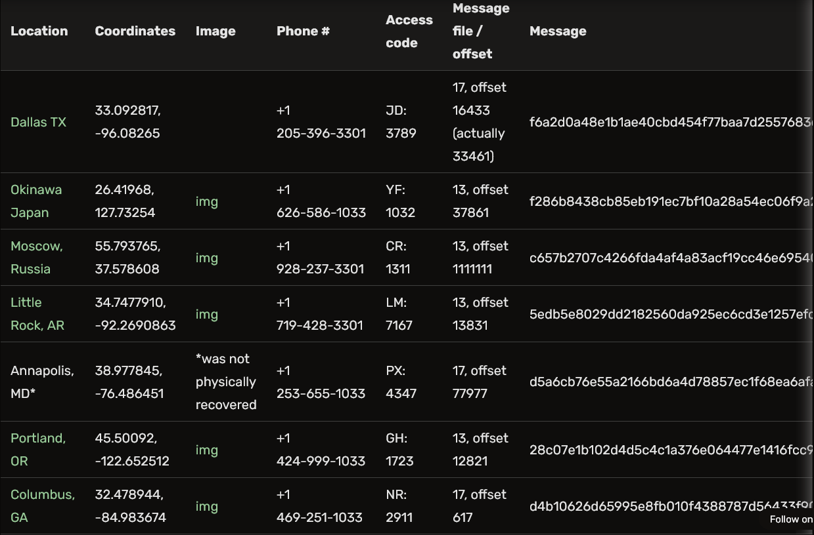

Once 5 of 10 SSSS codes had been retrieved, they could be [decrypted](http://point-at-infinity.org/ssss/demo.html) to form their message,

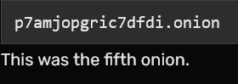

# What Happened Part 2 (2013)

The Questions

Upon entering their emails into the website, the solvers were given a set of test questions, and requested not to publish them. There were 19 questions in total, with three different types Here are the screenshots of questions as they were on. onion site: <http://imgur.com/a/YFA1a>

The first type of question gave a statement and then a multitude of answers, which were:

* True
* False
* Indeterminate
* Meaningless
* Self-Referential
* Game Rule
* Strange Loop
* None of the above

These statements were the following:

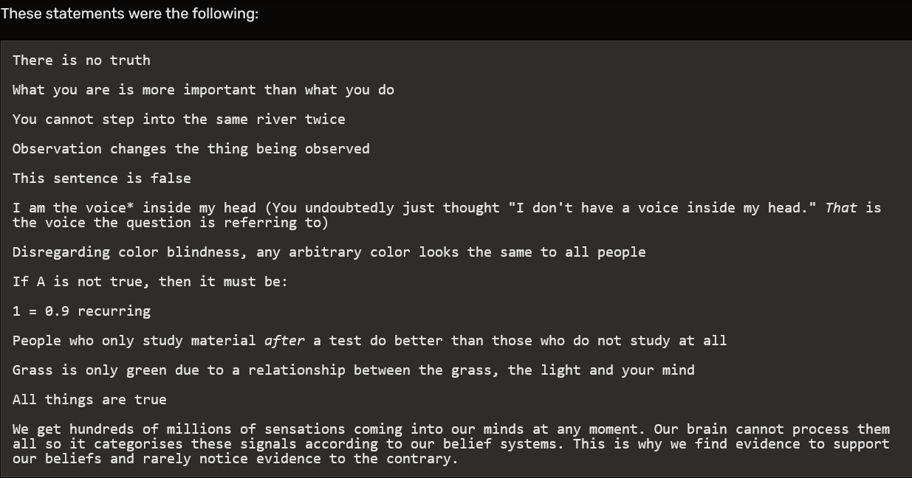

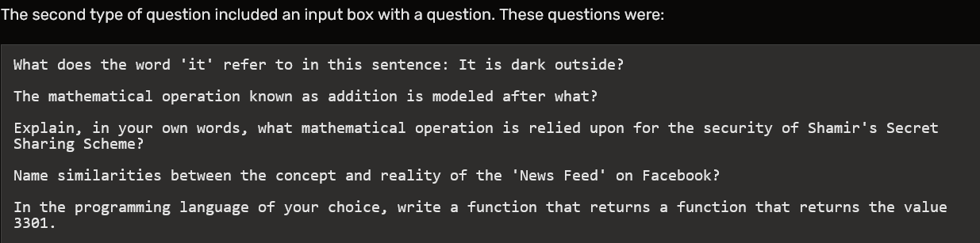

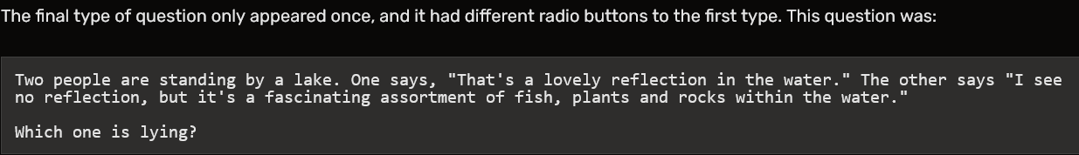

It has been noted that the abstractness of these questions is very similar to the questions that Google supposedly asks its interviewees for serious roles at the company. They can supposedly be used to determine a person's personality and type. Each question in the test was timed to prevent one from externally researching questions, and the questions chosen were in a random order from the above pool.This page also saved two cookies on the user's computer, which were:

167=6941f707ff39d259ff71657a79cb6b54c184d2f0455810109c1a960860bde0e6;

761=7bc1e7805ccfa518920f0d94fc4e8f7dbd83287a03b337b89109cd2287befae5;

Note that 167 and 761 are ~~palindromic~~ EMIRPS, primes which appeared earlier in the puzzleset (*The Instar Emergence* song is 2:47 long, or 167 seconds. Name of the file: 761.mp3.

*An* ***emirp*** *(prime spelled backwards) is a* [*prime number*](https://en.wikipedia.org/wiki/Prime_number) *that results in a different prime when its* [*digits*](https://en.wikipedia.org/wiki/Numerical_digit) *are reversed. A* ***palindromic prime*** *(sometimes called a* ***palprime****) is a* [*prime number*](https://en.wikipedia.org/wiki/Prime_number) *that is also a* [*palindromic number*](https://en.wikipedia.org/wiki/Palindromic_number)*.A* ***palindromic number*** *or* ***numeral palindrome*** *is a number that remains the same when its digits are reversed.*

*The Servers*

After completing the test each solver was sent the following email to the address they had indeed yes inputted. Please note that the GPG signature has been removed, but multiple sources have confirmed that they received this email.

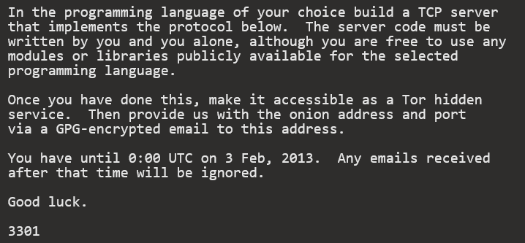

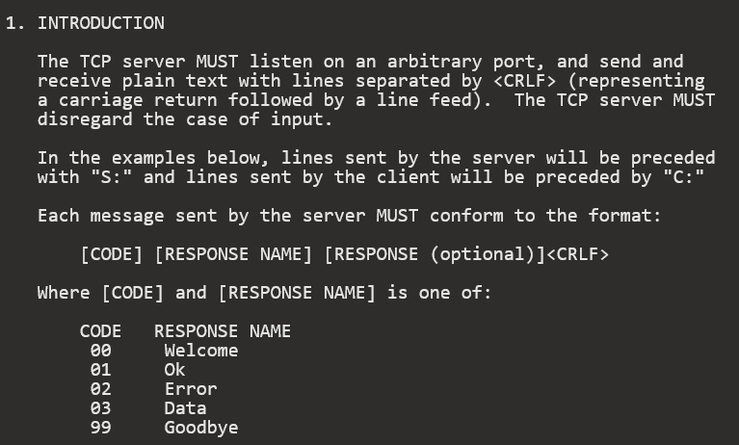

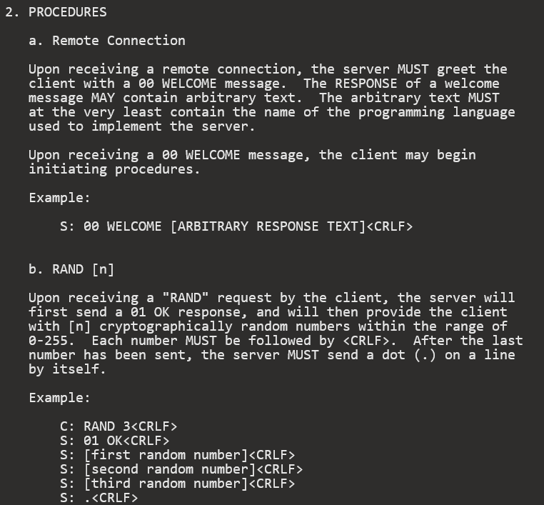

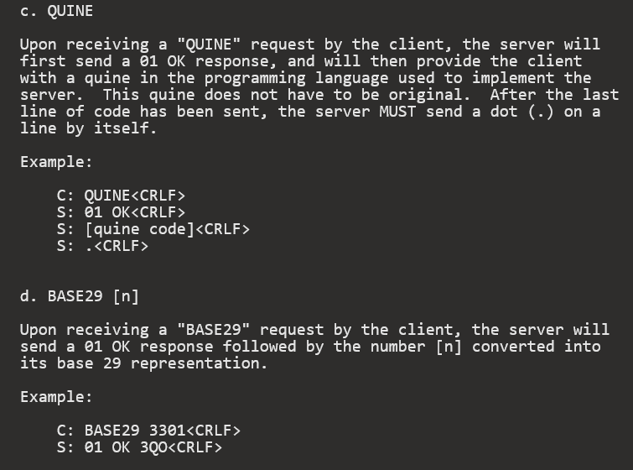

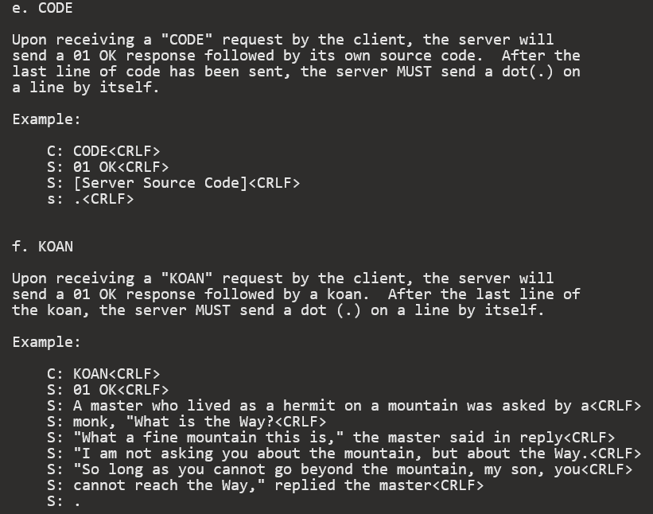

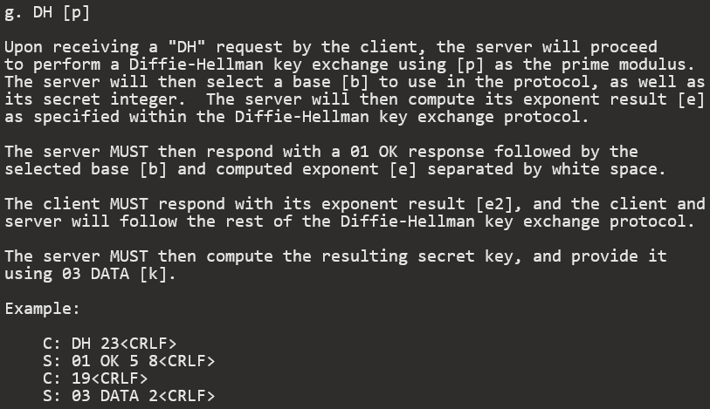

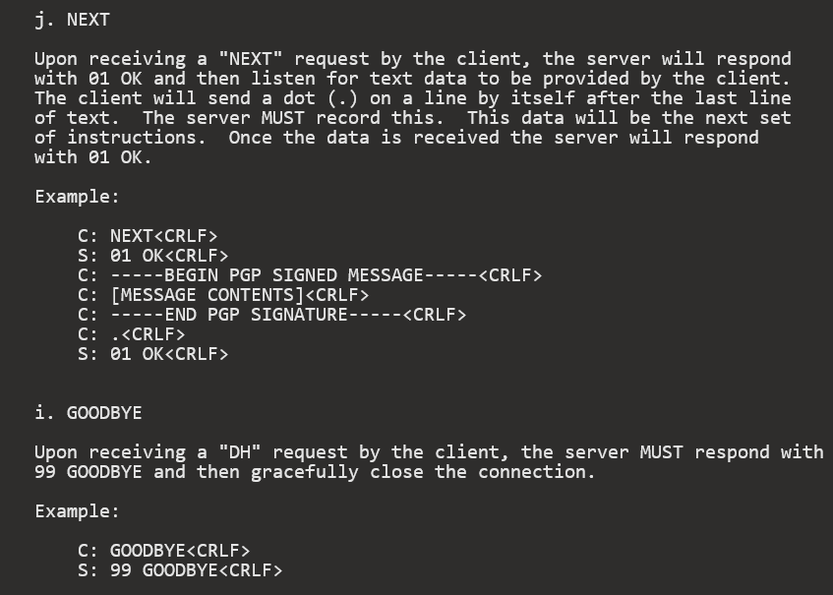

The solvers began work on their TCP server programs and submitted them by the deadline presented in the email. There was no response until two weeks later, when finally the TCP servers were pinged.

A log of one of the server testings is below:

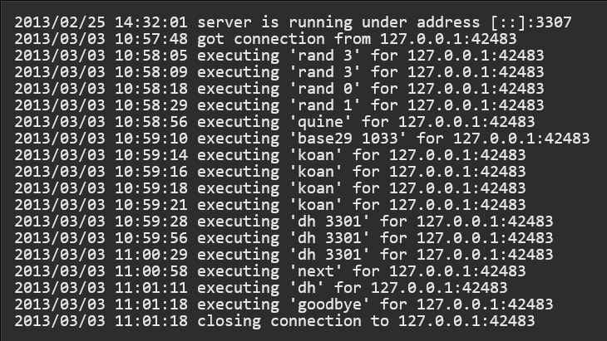

*The End?*

There were reports that stated they received a message similar to the [leaked email](https://uncovering-cicada.fandom.com/wiki/The_Leaked_Email) from 2012's puzzle. These reports initially could not be confirmed as no email was leaked until much later..

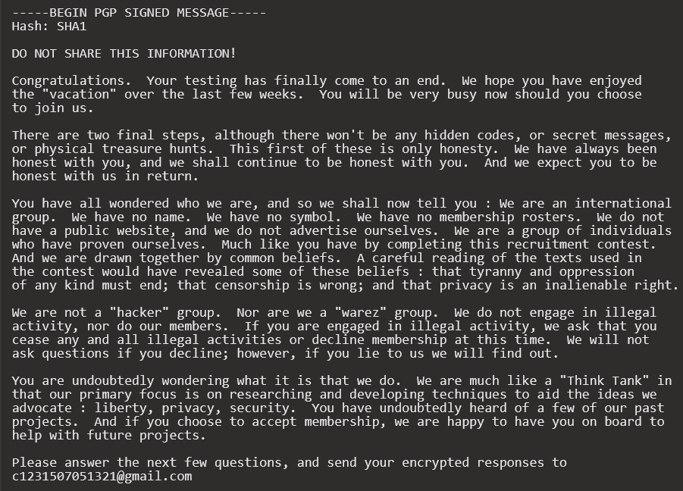

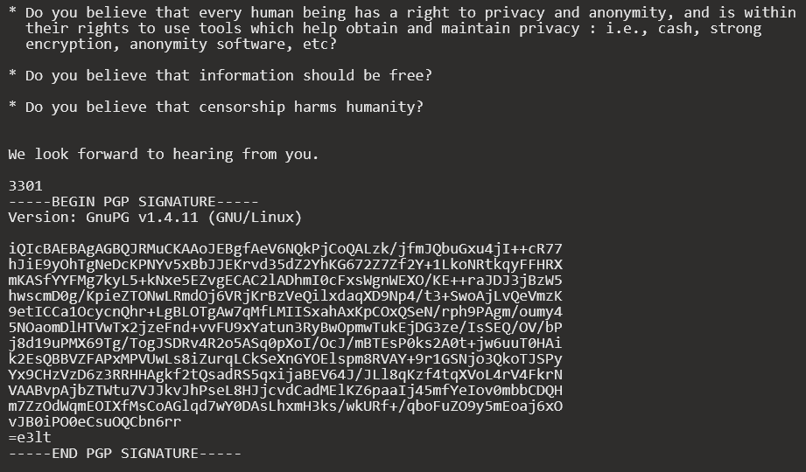

# What Happened Part 1 (2014)

*The Beginning*

In early January 2014, people gathered together on the net to wait for the next signs of life from Cicada 3301. After several fake puzzles, eventually a genuine message from Cicada was received. On January 6th, the T[witter](https://twitter.com/1231507051321) account used by Cicada in 2013's puzzle was re-examined; after being inactive for about a year, it suddenly tweeted a link to an image on [imgur](http://i.imgur.com/zN4h51m.jpg). In line with earlier rounds, this image contained a steganographically hidden message recoverable using the program [outguess](http://www.outguess.org/). Executing

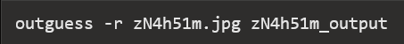

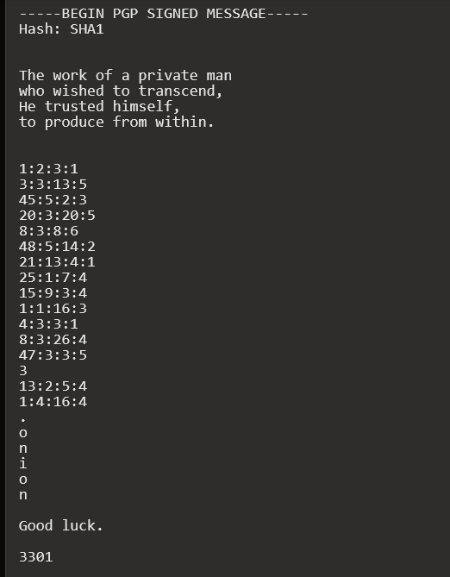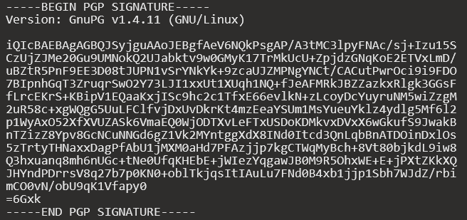

The Book Cipher

The message looked like a book cipher. Cicada has used book ciphers [in past years.](https://uncovering-cicada.fandom.com/wiki/What_Happened_Part_1_%282013%29#The_Law_.28Liber_AL_vel_Legis.29) Thanks to the hint in the beginning of the message the book was easy to find -- [Self-Reliance and Other Essays](http://www.math.dartmouth.edu/~doyle/docs/self/self.pdf) , by Ralph Waldo Emerson. To illustrate how to solve this cipher, take the first line of the message:

1:2:3:1

This line references the first paragaph of the text, the second sentence in that paragraph, the third word in that sentence and finally the first letter in that word. In this case the first character of the third word of the second sentence of the first paragraph in *Self-Reliance and Other Essays* is 'a'. Following this scheme for the rest of the cipher (the solitary 3 points to the third character in "Ralph Waldo Emerson", 'l') and appending ".onion" to the result yields

 which is the address of a Tor hidden service.

The First Onion

*The William Blake Collage*

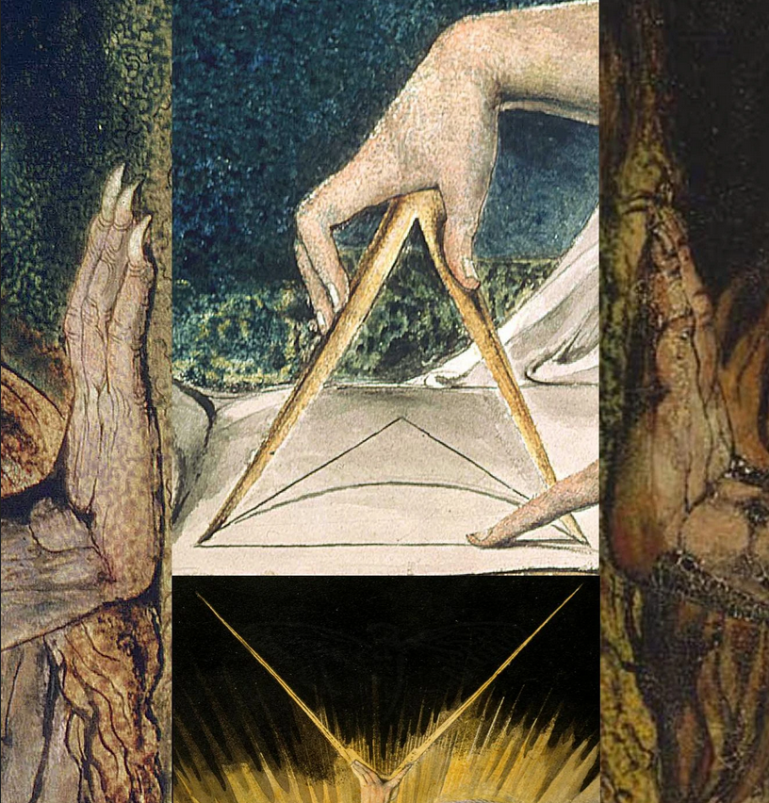

The hidden service featured [this image](https://uncovering-cicada.fandom.com/wiki/File:1033.jpg), which is a collage of four [paintings](https://uncovering-cicada.fandom.com/wiki/DEBATE_ABOUT_MEANING_OF_THE_PICTURE_ON_ONION) by [William Blake](https://en.wikipedia.org/wiki/William_Blake).

Following the usual procedure for investigating images, it was noticed that this image contains a message, again, extractable by outguess. The following is its content, omitting the PGP header and signature:

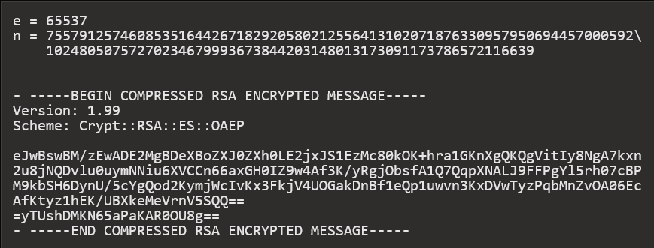

The message can be seperated into two parts. The first part, spanning the first 3 rows, declares two values, an *N* and an *e*. The next part, hugged by "*BEGIN COMPRESSED RSA ENCRYPTED MESSAGE*", contains information about an encryption scheme, also called a chiffre, as well as data encoded in [base64](https://en.wikipedia.org/wiki/Base64). Base64 is a scheme to encode unprintable bytes into printable characters.

The *Scheme* line tells us that the following message is encrypted using the cipher RSA. The next step was clear: decrypt the message. To do that, we needed something we didn't have: the private key. A brief explanation is in order.

*A Brief Overview of RSA*

RSA is a moderately complex cipher to understand; Numberphile provides a good introduction to the topic. Its main advantage is that, as a public key encryption scheme, it allows sharing of encryption keys without transmitting the key in plaintext or agreeing on a key in advance In RSA, *N* and *e* are variables commonly used in the mathematical aspects of the cipher. In fact, together they constitute the public key of an RSA keypair. The public and private keys are mathematically related. Without going too much into detail, they both are related to *N. N is* the product of two large primes, called *p* and *q*. If an attacker can factor *N,* which is publicly available, into its two prime factors *p* and *q*, then he can calculate the corresponding private key.

In reality, factoring large integers that have only two prime factors is a [computationally hard problem](http://en.wikipedia.org/wiki/RSA_problem) . In RSA, an *N* with 2048 or 4096 bits is typically used as the large size provides enough complexity to make the factorization of *p* and *q* computationally infeasible in the short term.

*Finding the Private Key (or, Brute Forcing RSA)*

To our luck, the *N* used to encrypt the message was far smaller than 2048 or 4096 bits. The *N* we were given was 432 bits (130 decimal digits) long.

The solving community exhausted a lot of options in an attempt to find the private key. They searched for suspicious information in the data provided until that point, investigated images, brainstormed correlations, followed connections and so forth. As time went on and nothing was discovered, the solvers began to discuss the worst case scenario: finding *p* and *q* via brute computational force.

We quickly agreed on [cado-nfs](http://cado-nfs.gforge.inria.fr/), a program designed to obtain the prime factors of large integers using a distributed network of machines (convenient to say the least). After about 8 hours of debugging, fixing, patching and testing as well as additional 9 hours of distributively working on the prime, the results were in:



These individuals successfully brute forced a 432-bit RSA key.

The Second Onion

*The Growing String*

After the successful decryption of the RSA message, we had a single resource:



This is the address of a Tor Hidden Service. Upon visiting the service, the following document was displayed:



The page appeared to be static. However, after some time, we noticed that the string was slowly growing. Every few minutes, two characters were appended to the end of the string. This process continued for approximately 23 hours. The time intervals between new bytes were found to be multiples of five. Various users recorded the minutes between updates, the time that they occurred, and the data appended at those times.

<http://pastebin.com/5bTLHqCN>

<http://imgur.com/lTRRxTT>

<http://pastebin.com/qn8jmPJr> (GMT +1)

<http://i.imgur.com/prAeqPS.png>

The above datasets are most likely not complete, and no guarantee of accuracy is made. After 23 hours, the process stopped and no more characters/bytes were appended to the string. The final string was:



This string is 512 characters long. We assume it is hexadecimal. However, about an hour after the string finished growing, at approximately 05:31:40 GMT the document changed. The old 512-character code was gone, along with the HTML comment. In its place was the following document:

<https://infotomb.com/oyfhl.txt>

backup: [sprunge](http://sprunge.us/VHRH)

We link to it because it is very large.

Note that the HTML comment was changed from

**<!--Patience is a virtue-->**

to

**<!--761-->**

This is significant. We noticed that, by applying the Gematrius Primus from the 2013 puzzle to the phrase 'Patience is a virtue' and summing the result, one obtains 761. The number is also a palindromic prime.

The new string was 3641299 (?) characters long. We noticed that it contained a significant amount of repeated text.

Analsysis of this [new string](https://infotomb.com/oyfhl.txt) revealed that it contained three JPEG image files. This was discovered when we:

1. Converted the string into its binary representation
2. Flipped all the bits (i.e. 0 becomes 1, 1 becomes 0) [Note: this is equivalent to XOR 111111]

Looking at that XOR'd binary string, we noticed that the first two bytes were

**0xFF 0xD8**

Wikipedia tells us that these are the first two bytes of a JPEG image. We walked through the data left to right, and later on in the string, we discovered the same byte sequence again. This indicated the presence of more than one JPEG image. We analysed the rest of the string in a similar fashion, and discovered a total of three JPEG images. The third JPEG image was in reverse order, and so had to be un-reversed.

For further clarification, the order was this (.... = JPEG data, [ ] = one complete image):

**[0xFF 0xD8........................][0xFF 0xD8........................][........................0xD8 0xFF]**

After transforming the bytes into their proper JPEG format (note that you must reverse the byte sequence of the third image before doing this):

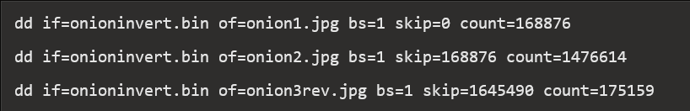

we obtained the following three images:

# 

*Image Analysis*

Each of the images contain hidden messages and other information. These were found and analyzed simultaneously. As a result, this section does not proceed in chronological order.

***Intus***

# 

***Liber Primus***

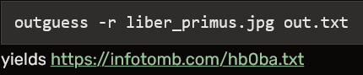

***Runes***

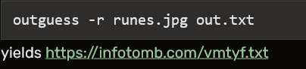

2014's image as 'Gematria Primus 2014'. **It is paramount to understand that 2013's image was created by Cicada 3301, while 2014's was created by puzzle solvers and was created from rearranging 2013's image.**

Using the Gematria Primus 2013, the runes in the 'Runes' image become:

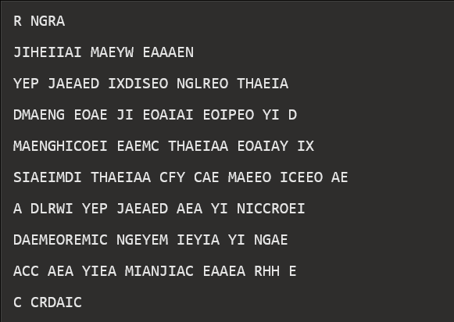

This stumped us for a short while. Then, someone created Gematria Primus 2014 by rearranging Gematria Primus 2013. From Gematria Primus 13, take the left block of three columns and stack it on top of the right block of three columns. Then, find the letter you wish to decode. Find the position of that letter in the vertical list, beginning at the top. Take that number and find the character that many characters into the list, from the bottom up. Applying this process to each letter/rune yields (newlines added for readability):

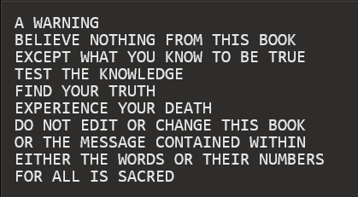

By substituting each character for its respective value in Gematria Primus 2013, we noticed that the sum of each line adds up to a prime (emirps marked by *):

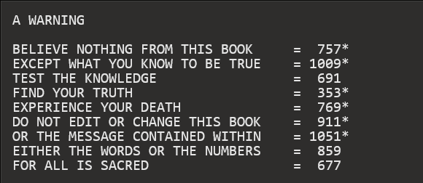

The 5 Gram Message

Shortly after the warning in the previous section was found, it was discovered that by XORing the hexadecimal messages hidden within each of the three images the following message resulted:

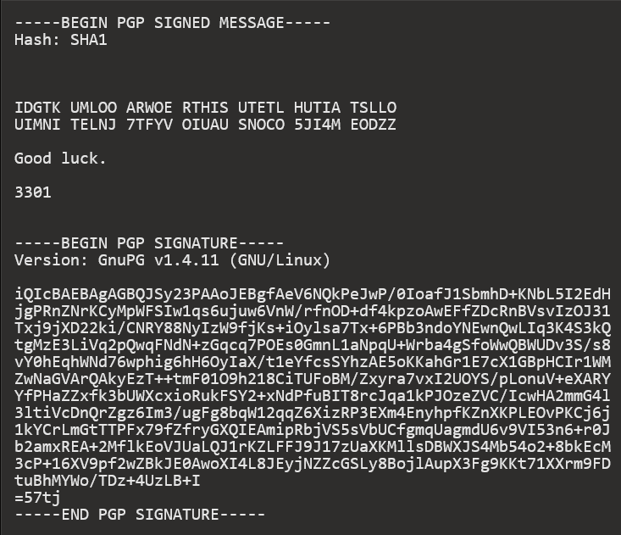

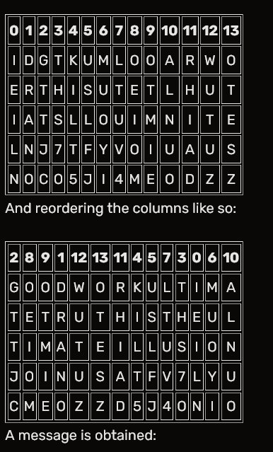

A message is obtained:



Assuming that the final N was omitted in order to fit the bounds of the column transposition cipher, and applying proper formatting, the following Tor hidden service address is obtained:

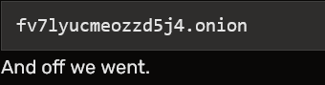

The Third Onion

*This onion has since been taken offline.* *In this section the puzzle fractures into several directions. The author has chosen not to subdivide this section and instead opts for pure chronological formatting. Events in this section are detailed in the exact order they occurred.* The first visitor to this hidden service was greeted with a blank page. The page remained blank for a short time and then changed to the following document:

**<!--1033-->**

**87de5b7fa2**

As with the RSA onion, the string slowly grew over time, with two new characters (one byte) being added at widely varying intervals. Some timing data was collected for further analysis. In the meantime, a solver ran the tool [DirBuster](https://www.owasp.org/index.php/Category:OWASP_DirBuster_Project) against the hidden service and discovered an apparent misconfiguration of the backend Apache server. The server was leaking a system status page. Whether this was intentional is unknown. However, shortly after the page was discovered, it appears that Cicada was alerted that the status page had been discovered because the content of that page changed. Appended to the end of the server status was yet another very long string. This string was found to contain two image files in a similar ordering as the RSA onion, except that there was some data between them (OOB or Out Of Bounds data):

**[0xFF 0xD8..............................] [Data in between JPGs] [..............................0xD8 0xFF]**

After building the first JPG from the hex:

**xxd -p -r < server-status.hex > server-status.jpg**

One obtains the image shown below on the left. Doing the same for the reversed copy of the second JPG yields the same image as the first, shown -- except for that OOB data.

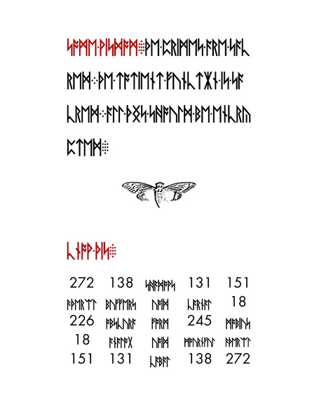

Comparing the first and second images

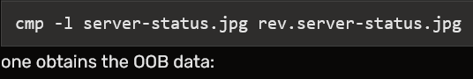

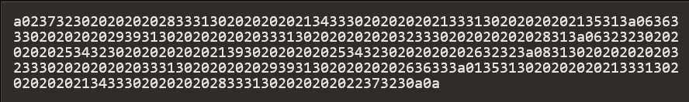

Converting this string to binary:

**xxd -b oob.hex oob.bin**

**and reversing that::**

**xxd -r oob.bin oob-rev.bin**

we obtain:

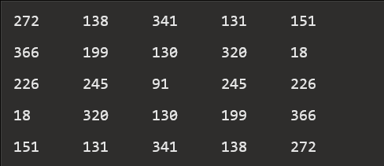

Among other things, this is a magic square whose magic number is -- you guessed it -- 1033.

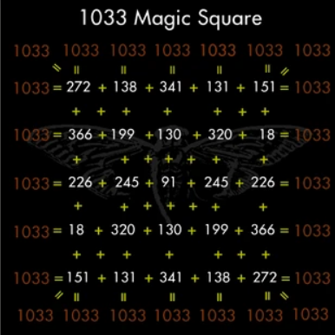

For those following along, here's a nice one-liner to get that matrix from the original image:



Runes were unencrypted. With matrix and Gematria Primus 2013 in hand, we began to interpret the runes in the image. The runes in the upper half of the image read:

**SOME WISDOM**

**THE PRIMES ARE SACRED**

**THE TOTIENT FUNCTION IS SACRED**

**ALL THINGS SHOULD BE ENCRYPTED**

In the bottom half of the image, the red runes read: **KNOW THIS: The table underneath, translated to value form using Gematria Primus 2013, yields**:

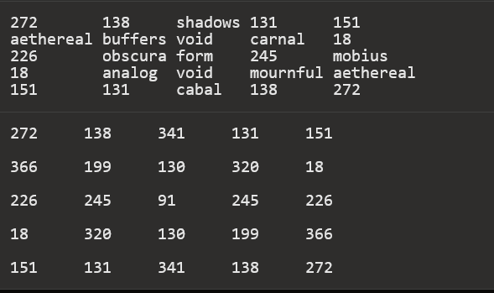

which is the exact same matrix found earlier from the OOB data. About a day went by with little activity other than speculation on the meaning of this matrix. Then the string from the main page stopped growing. According the the HTTP header, the final update occurred on January 11 at 01:09:01 GMT. The final document was:



The final string was 512 characters (assuming hex, 256 bytes or equivalently 2048 bits). It was observed that this string matched the growing string from the previous onion. On January 11 at 10:07 UTC, the Apache server status page changed once again to display a new hexadecimal string: <https://infotomb.com/laqs9.txt>

This string contained the following two images in the same style as before

**[0xFF 0xD8...............] [...............0xD8 0xFF]**

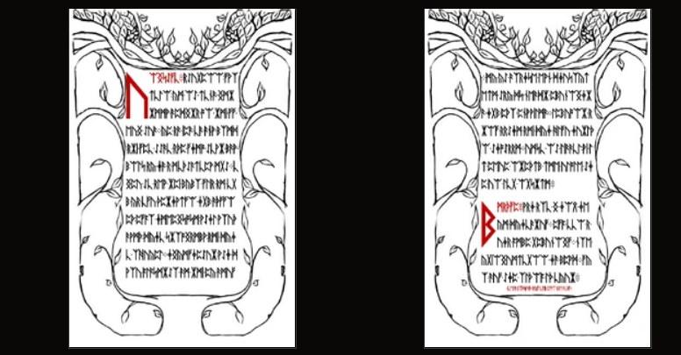

*First Image*

Outguessing the first image yields a signed message: <https://infotomb.com/t5uuz.txt>

The hex string from that message encodes a JPG image:

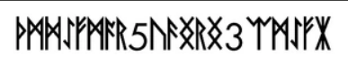

The runes in this image were solved later (read on). Translating the runes from the first image with Gematria Primus yields :



After some time with trial and error, it was discovered that this ciphertext had been created with a Vignere cipher.

[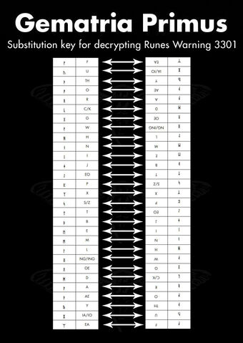](https://static.wikia.nocookie.net/uncovering-cicada/images/6/66/Runes-warning.jpg/revision/latest?cb=20140108163159)

The key was DIUINITY (divinity) and used the reversed gematria as shown here Every time you reached an F it was left unencrypted, and it reset the running key.

Reversing the cipher yields:

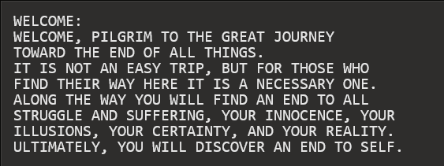

*Second Image*

Outguessing the second image yields garbage output. The runes on it translate to:

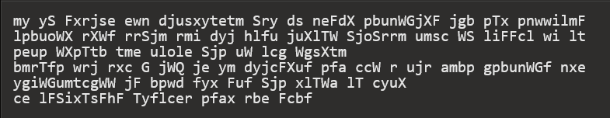

After reversing the Vignere cipher:

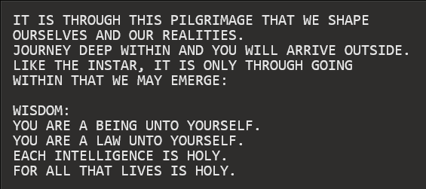

The red footer of that page reads

**AN INSTRUCTION: COMMAND YOUR OWN SELF :**

**Back to the server page:** Fourteen minutes after the status page update containing the two above images, on January 11 at 10:22 UTC the status page changed once again:

[https://infotomb.com/hw0l5.txt](http://web.archive.org/web/20160122203114/https:/infotomb.com/hw0l5.txt)

The first image from the previous update remained intact in the new string. However, the data of the second was replaced almost entirely with different hexademical. Attempting to render it as a JPG yields a corrupt and incomplete image.

**Outguessed Image Solved**

The runes in the small outguessed image obtained from the first new page were also encoded with a Vignere cipher. Using the key

we obtained the Vignere offsets

**22, 11, 9, 24, 26, 10, 11, 16, 19, 9, 23, 25, 19, 10, 13, 26, 27, 11**

and using these offsets to decode the original runetext we obtained

**A U O W Y F X L 5 L C S F J 3 N O N IA N**

which formatted as a hidden service address yields

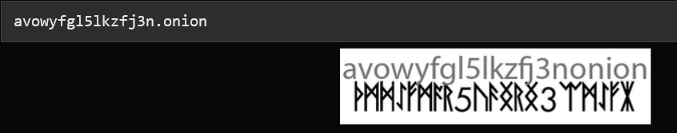

The Fourth Onion

*This onion has since been taken offline.*

Upon visiting the fourth onion we were greeted with the following document:

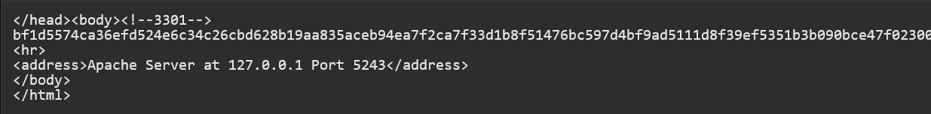

This string is 512 characters (256 bytes). Shortly after the discovery of this string the onion went offline. until January 29 at 00:05 GMT, when it came back online. This time it contained no HTML. The sole content of the page was a signed message. The content of the message was a hex string (with newlines):

<https://infotomb.com/vnq3e.txt>

This string began with the bytes

**0x1F 0x8B**

indicating the string was a gzip file. Converting to binary

**xxd -p -r onion4.hex onion4.gz**

using file to confirm type

**$ file onion4.gz**

**onion4.gz: gzip compressed data, was "data.out", from Unix, last modified: Fri Jan 24 15:10:12 2014**

and unzipping

**gzip -d onion4.gz**

we are left with binary data containing four images:

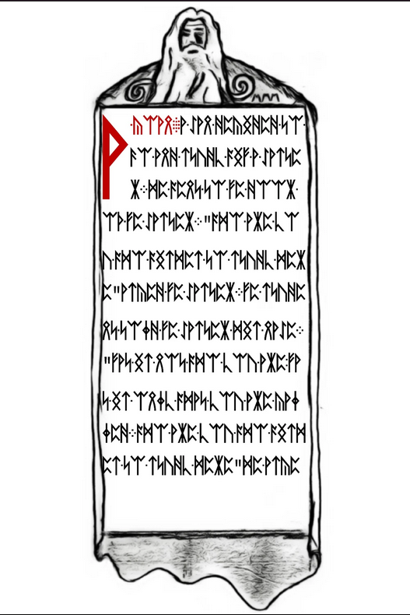 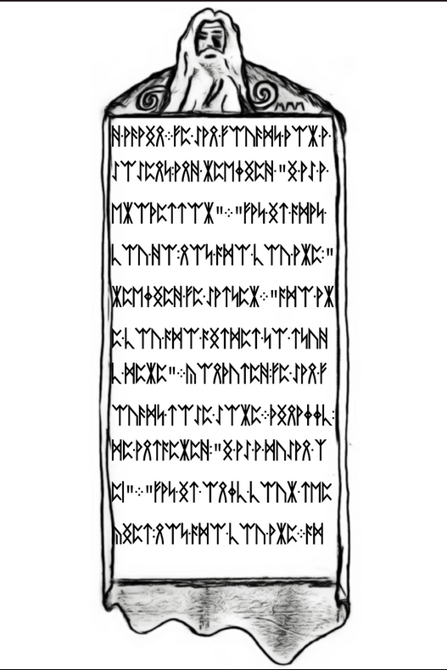

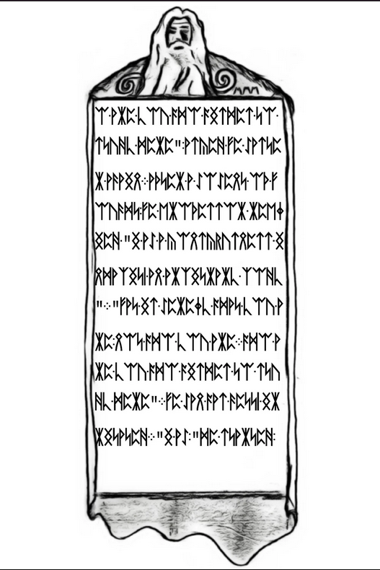 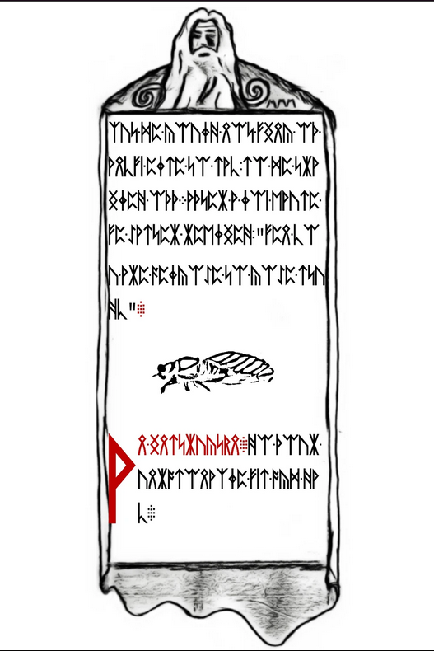

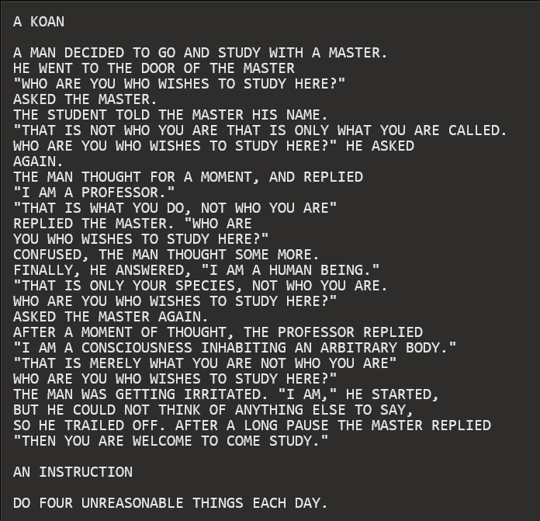

The following image

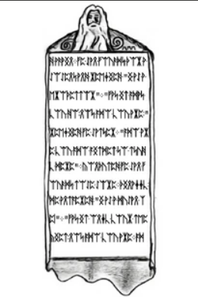

when run through outguess

**outguess -r onion4image3.jpg out**

contains a message

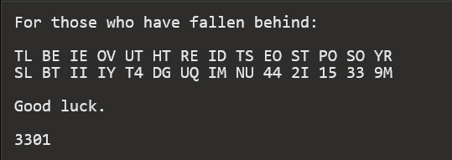

This ciphertext was found to be encoded with a columnar transposition cipher. Period = 7, key = 1736254.

Cleartext:

**TOBELIEVETRUTHISTODESTROYPOSSIBILITYQ4UTGDI2N4M4UIM59133**

Which of course translates to

**TO BELIEVE TRUTH IS TO DESTROY POSSIBILITY Q4UTGDI2N4M4UIM59133**

Formatting that last bit as an onion url yields

**q4utgdi2n4m4uim5.onion Purpose of 9133 at the end of the string** [**was not discovered**](https://uncovering-cicada.fandom.com/wiki/CICADA_3301_2014_PUZZLE_FACTS_PART_6#Outguess_and_a_Transposition_Cipher)**.** bringing us to

*The Fifth Onion*

*Interconnectedness*

The fifth onion contained [a PGP signed message](https://raw.githubusercontent.com/micheloosterhof/cicada-2014/master/stage07/q4utgdi2n4m4uim5.onion/index.html). Shortly afterwards it went offline. Converting the hex string to binary

**xxd -p -r onion5.hex onion5.bin**

and checking with file

**file onion5.bin**

tells us that it is an mp3 file. Renaming as such

**mv onion5.bin onion5.mp3**

and reading the ID3 tags

**id3v2 -l onion5.mp3**

shows

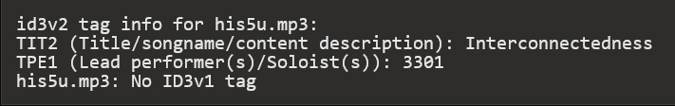

Thus the name of the song is 'Interconnectedness', and the artist is '3301'. Translating each character of the word 'Interconnectedness' to its corresponding numerical value with the Gematria Primus 2013 and summing yields 772 (when reversed, a prime). The song itself is 277.133 seconds long.

*The Portrait*

On January 31, Onion 5 came back online. This time it contained an image:

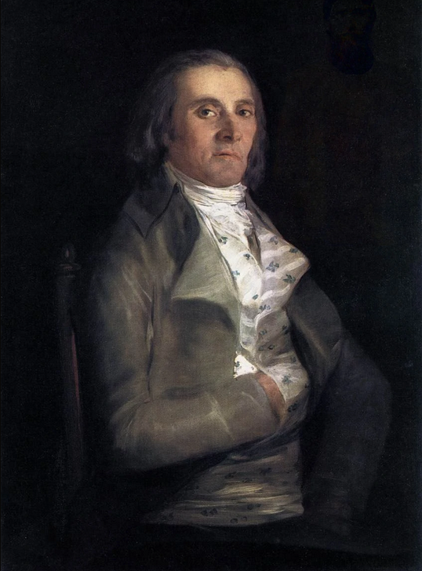 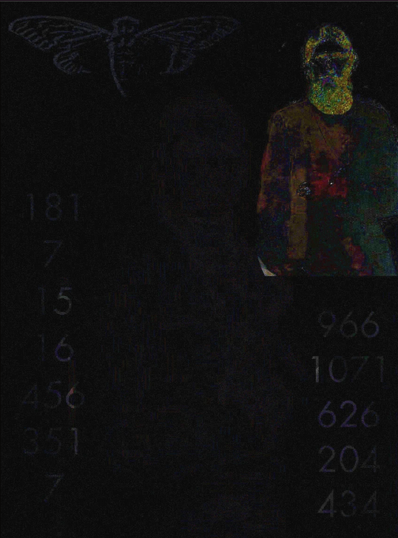

This painting is *Portrait of Andrés del Peral* by Goya y Lucientes. The significance of this is indeterminate. Adjusting image filters reveals some hidden information, shown in the gallery above in the second image. An image of a man - Grigori Rasputin - was superimposed in the upper right corner. Again, this has yet to be found significant. The cicada logo is present in the upper left of the image. There are also two columns of numbers in the bottom left and bottom right corners, neither of which have been significant. They are, left to right

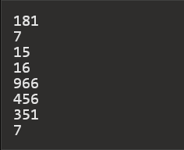

which sums to 1033; and

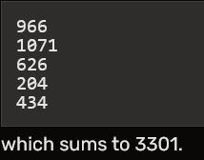

Applying outguess to the original portrait

**outguess -r onion5portrait.jpg onion5portrait.outguess**

and checking the output with file

**file onion5portrait.outguess**

indicates that the retrieved data is a bzip compressed file. Decompressing

**bzip2 -d onion5portrait.outguess**

gives us a [text file](https://github.com/micheloosterhof/cicada-2014/blob/master/stage08/index) with a signed message.

*Hex Blocks*

Breaking up the three hex blocks in the message and using xxd to convert to binary yields two JPG images and an MP3 file.

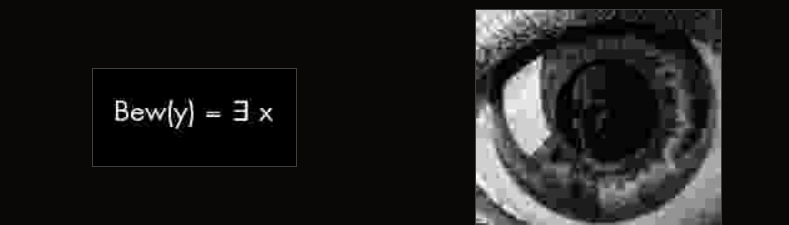

The equation in the first image is part of the **Godel** incompleteness theorem. [The mp3 file](https://github.com/micheloosterhof/cicada-2014/blob/master/stage08/index.3.mp3) is a three second segment of **Bach'**s Trio Sonata in G Major (BWV 1039). ([Some say](http://www.clevcode.org/cicada-3301/) that it is BWV 1033) The picture of the eye is a painting by M.C. **Escher** called 'Eye', painted in 1946.

The last bit of the signed message

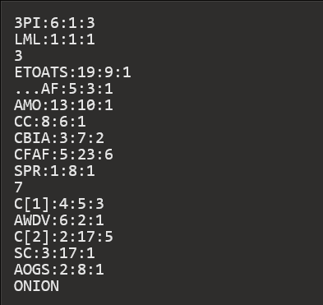

is a book code. The key is ***Gödel, Escher, Bach****: An Eternal Golden Braid* by Douglas Hofstadter. The format of the code is

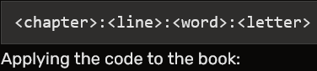

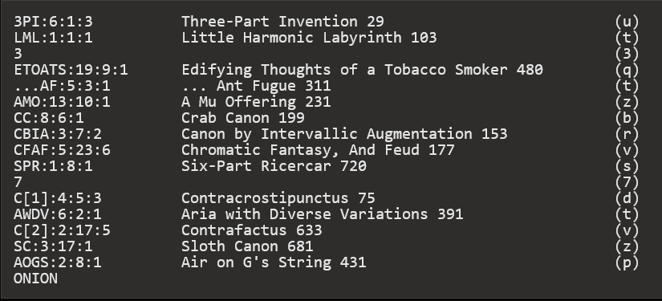

yields

**ut3qtzbrvs7dtvzpONION**

and formatting correctly yields

**ut3qtzbrvs7dtvzp.onion**

bringing us to

The Sixth Onion

**ut3qtzbrvs7dtvzp.onion**

The first thing found at this onion address was a large block of hex after the HTML comment The hex was

<https://infotomb.com/hrz8z.txt>

It contained four JPEG images in sequential, non-reversed order. They are

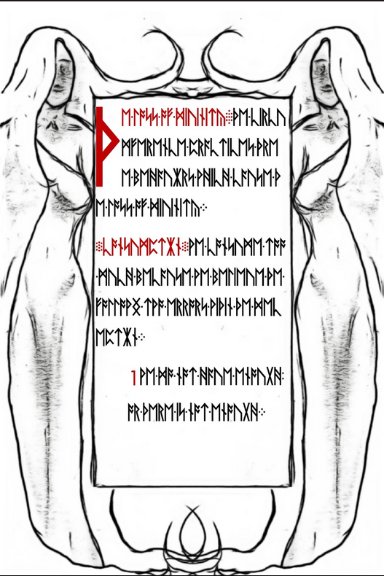 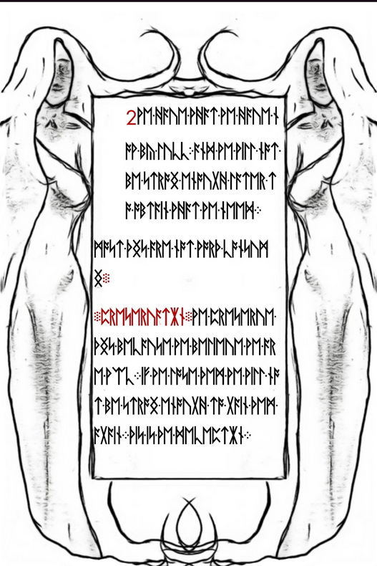

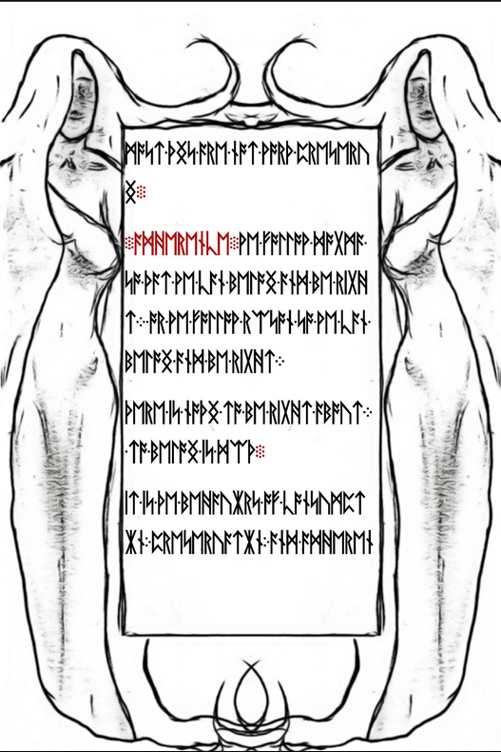 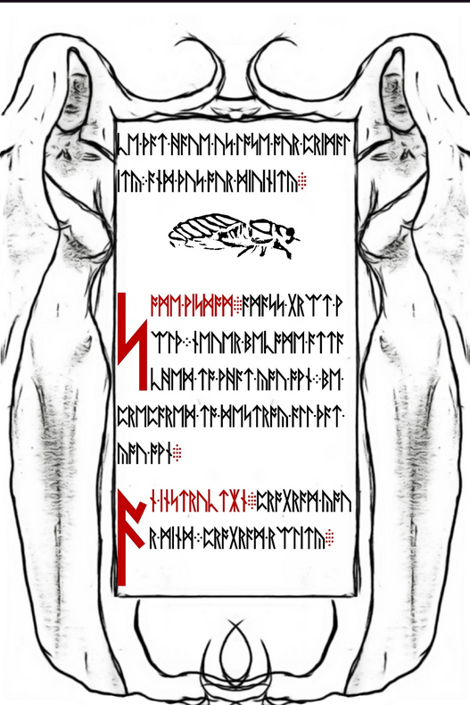

The runes were not enciphered, and they read:

Page 1:

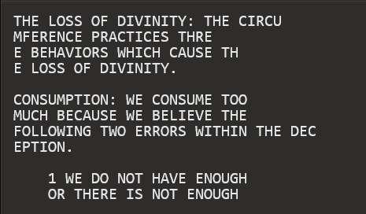

Page 2

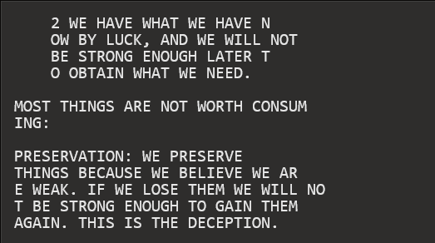

Page 3

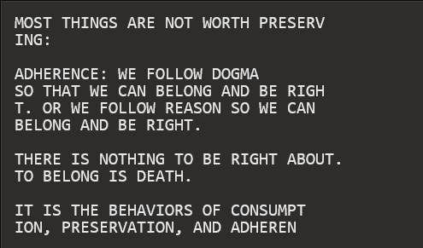

Page 4

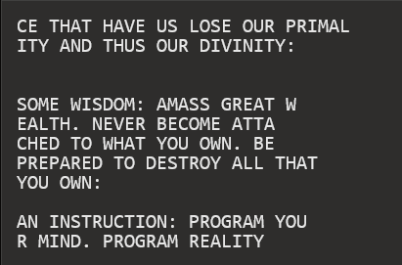

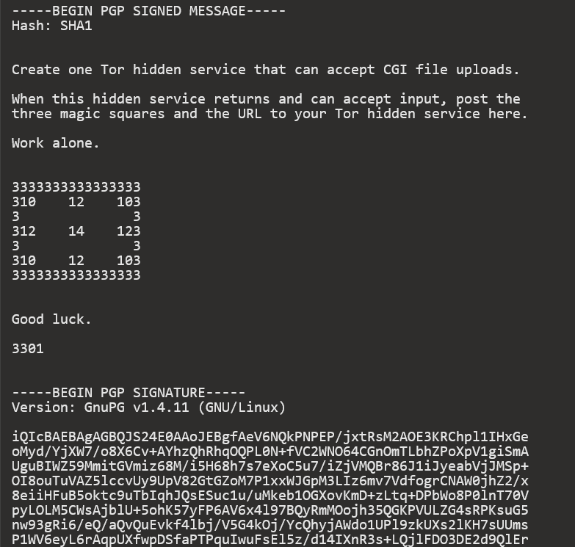

Note the number square (not magic) in the middle of the message:

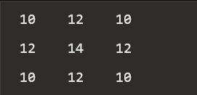

The only difference between the messages in each image was the number used to make the border of the number square. Page 1's outguess (above) used '3', page 2 used '3', page 3 used '0', and page 4 used '1', spelling out 3301. The onion went offline shortly afterwards. Six days later it came back online, sporting the following message:

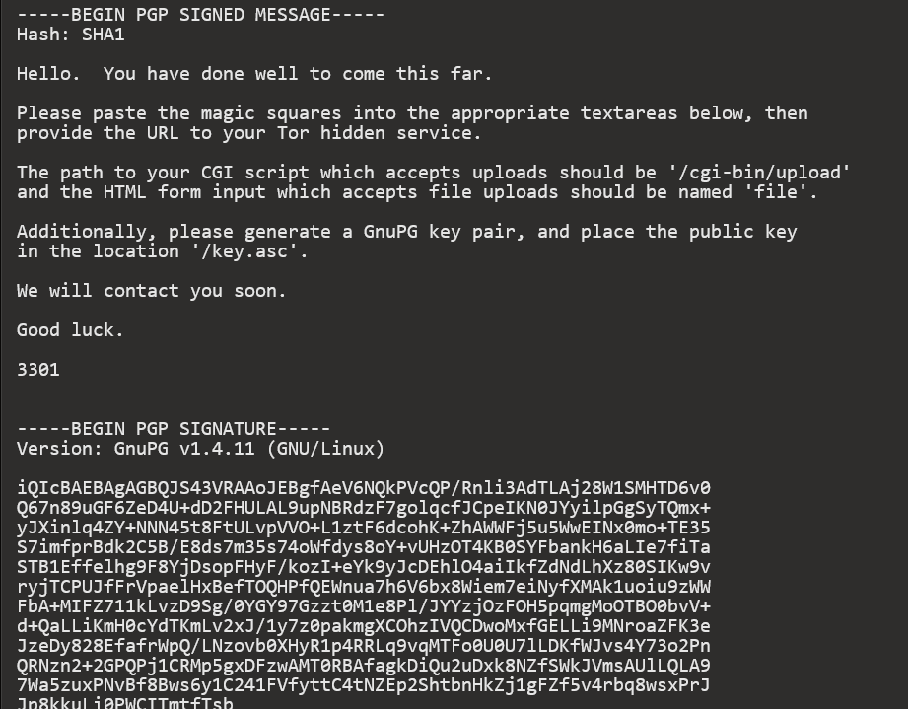

and then three text boxes where the referenced 'magic squares' had to be pasted. At the bottom was a text box for the onion url of the hidden service mentioned in the previous message. Screenshot of the page:

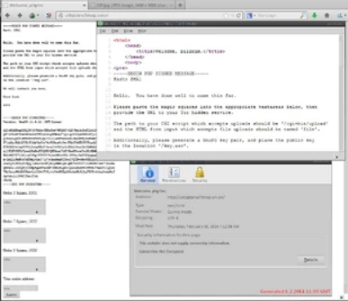

The page accepted any magic square that matched the criteria (e.g. first box square had to be order 5 and sum to 3301). Some time after this, it was discovered that the mp3 'interconnectedness' found on Onion 5 contained steganographically hidden data. The tool used to hide this data was 'OpenPuff'. The data hidden was a text file named 'magicsquares.txt' containing the following:

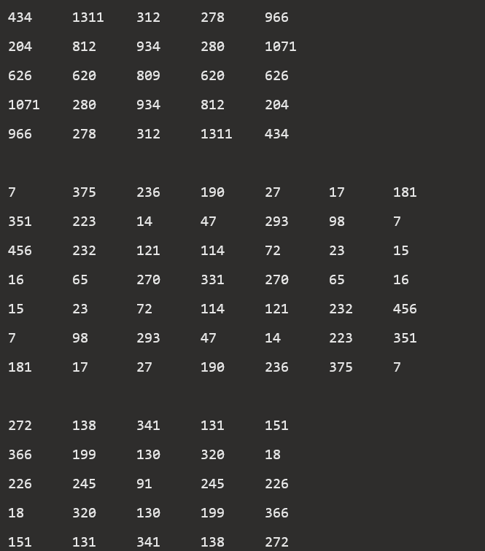

Two order 5 and one order 7 magic square, summing to 3301, 1033, and 1033. Upon submitting these squares and a link to your hidden service, the following page displayed:

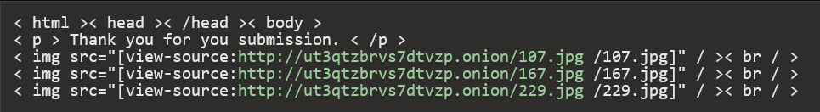

Note that the <html> tag is not properly closed. The images on the page:

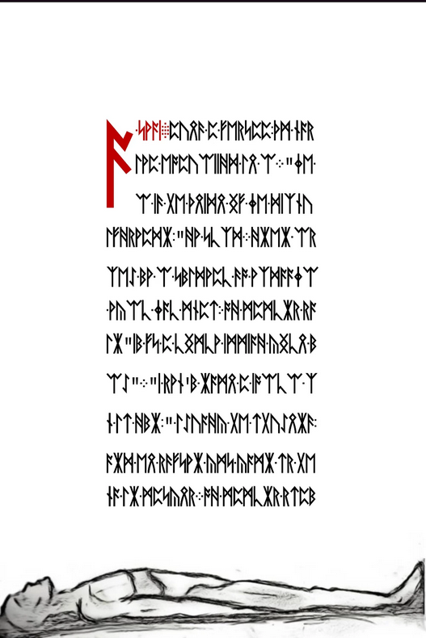 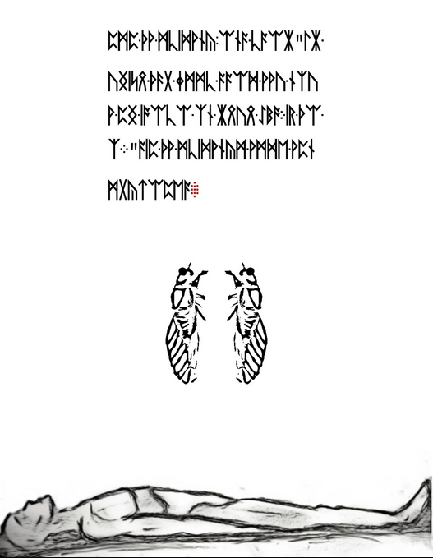

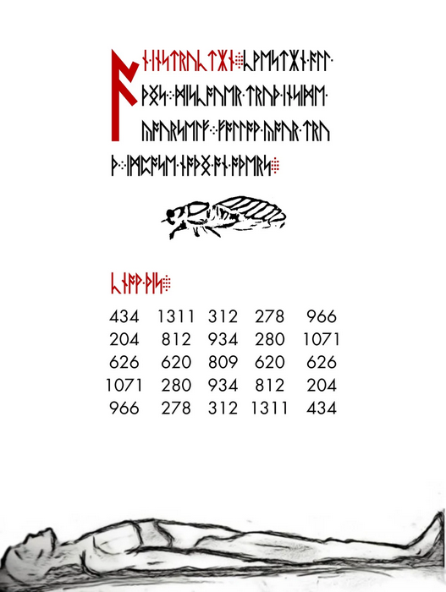

Decoding the runes on the page using a Vigenere cipher and key FIRFUMFERENFE (from CIRCUMFERENCEyields

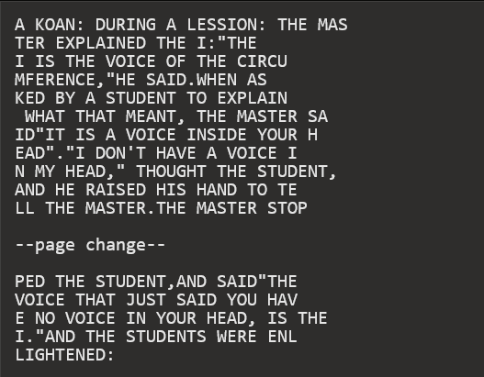

The text on the final page is not encoded beyond runes to English. Transcription via Gematria Primus yields:

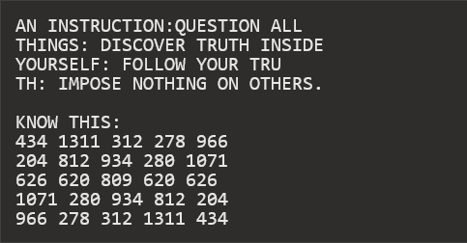

# What Happened Liber Primus (Post 2014)

*A Life Sign*

On May 2nd, 2014 at around 10:00 GMT, 3301 sent out messages to all of the hidden services previously registered on Onion 6. The requests made on the hidden services looked like this:

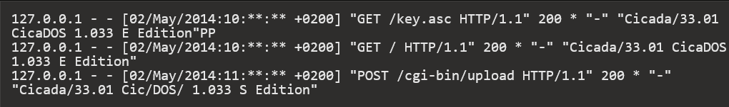

They requested the public key and and the root before uploading a file named message.txt.asc to the hidden service. The file contained a valid signature and a link to a new onion (ky2khlqdf7qdznac.onion). As it appears, the emails sent to different people were identical.

Content of message.txt.asc: <http://pastebin.com/x4Bm1v6h>

The GET request was made by Cicados 'E Edition' and the POST by 'S Edition', E and S are the 5th and 19th letters in the alphabet, with S being 7th letter from the end of the alphabet ie 5 and 7.

The message.asc.txt file is malformed with non-visble ascii spaces in the message that provide a hint in the form of the prime number sequence with the digit 19 missing.

Linked below is a screenshot of the message.asc.txt file so you can see how the numbers are encoded:

<http://imgur.com/wayVO26>

In July 2015, a similar sequence of spaces was found within the PGP signed pastebin message that was published from the Cicada twitter account (<https://twitter.com/1231507051321>). This sequence can be seen here:

<http://imgur.com/XtM8Yk9>

**Onion 7 - ky2khlqdf7qdznac.onion**

The onion from the message was running a thttpd server, version 2.25b. It was modified on April 2nd 08:33:19 GMT, meaning it took 3301 one month to set the website up and they let us wait another month before finally uploading a message.

Header:

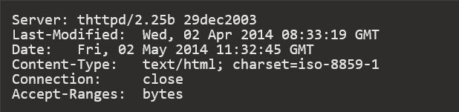

Requesting a non-existent file resulted in a 404 page giving the port used by the server:

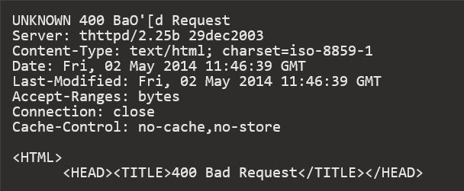

<BODY BGCOLOR="#cc9999" TEXT="#000000" LINK="#2020ff" VLINK="#4040cc">

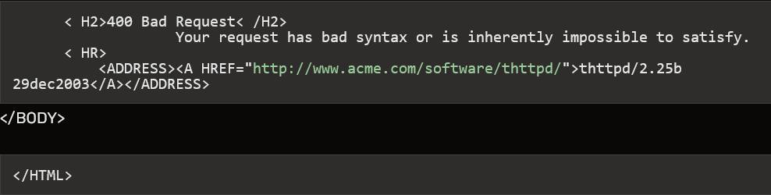

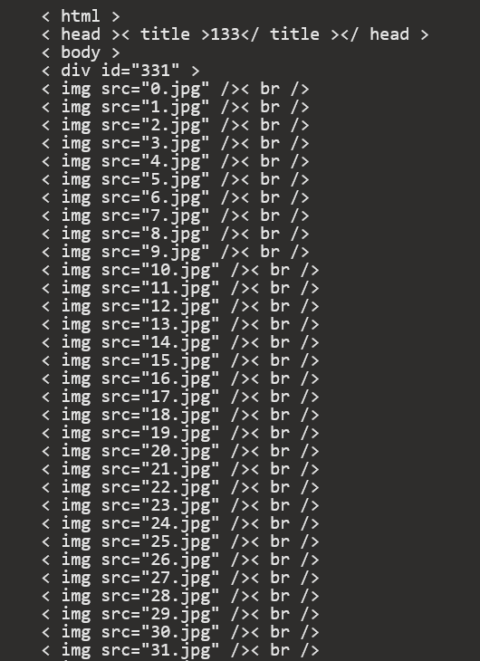

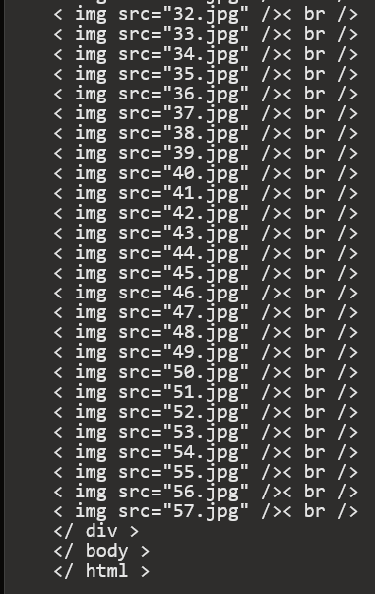

The onion contained 58 pages, numbered 0.jpg to 57.jpg, all written in runes and apparently part of the Liber Primus:

<http://imgur.com/a/8xnWx#0>

**Rune Pages, HTML File and message.txt.asc**

A drop box of all unmodified files is available here:

<https://www.dropbox.com/sh/lkta4q921vliyuw/AADmZ1YUHXWSjSizlMGZHXVMa?dl=0>.

<https://github.com/rtkd/iddqd/tree/master/liber-primus__images--unsolved>

<https://github.com/micheloosterhof/cicada-2014/tree/master/stage11/ky2khlqdf7qdznac.onion>

Imgur gallery: <https://imgur.com/a/8xnWx#0>

Transcription of all pages (including previous solved pages): <https://github.com/rtkd/iddqd/blob/master/liber-primus__transcription--full/liber-primus__transcription--full>

Transcription in latin letters (might contain errors): <https://titanpad.com/vFCy7T5p0O>

*Rune Page Sets*

The rune pages appear to be in sets of various length as defined by decorations in their margins and a discussion on their meanings can be found here: <http://archive.4plebs.org/x/thread/14547165/>

[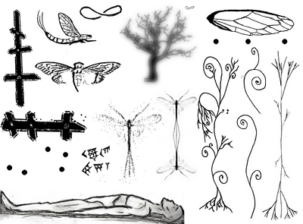](http://uncovering-cicada.wikia.com/wiki/File:1399181864285.png)

Several of these symbols are repeated on pages of the Liber Primus received earlier but are reversed (ie the cicada emerging and the reclining man). Some symbols repeat across the page sets and are also similarly transformed by rotation or mirroring (ie the 5 dots and infinity or mobius symbol):

34.jpg to 39.jpg - cuneiform numbers, the Babylonians, sexagesimal numeral system, possible hint to base 60

7.jpg, 23.jpg and 56.jpg - 5 dots in various transformations

24.jpg to 26.jpg, 57.jpg, 14.jpg - Mayflies, Ephemeridae, possible hint to ephemeral cipher

8.jpg to 14.jpg, 32.jpg and 55.jpg - Dendrites in various forms, inverted

It is likely the decorations provide an indication of how to decode the pages within a set or provide a path through the different page sets. This hypothesis is reinforced by adjusting colour levels on the images to reveal what appears to be further information:

<http://imgur.com/a/u2Ir4#0>

Transcription of Runes

A **numerical transcript** is available here: <https://raw.githubusercontent.com/remlong/cicada-runes/gh-pages/runes.txt> . The runes were numbered 0-28. Each page is on a new line and all spaces and symbols are underscores.

*Decryption of page 57 and 58*

Page 56

Page 56 was decrypted using a running stream of the Totient function, and a modulo of 29, both things used repeatedly by Cicada so far. For practical purposes, the totient function of a prime is that prime -1. This means to decrypt this page, shift the runes with a stream of (prime numbers, modulo 29) -1 ie 1,2,4,6,10,12,16,18,22,28,1,7,11,13.....Modulo 29 is used because there are 29 runes in the gematria so you only need the remainder of (Prime-1)/29 to determine and simplify the shift.

Page 56 decodes to:

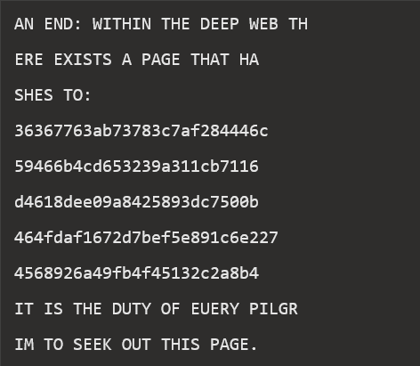

This could be interpreted as the hash of an onion page, however it should be noted that hashes can be used as unique file identifiers for deep web applications such as Freenet, Gnunet or P2P file sharing systems.

**Page 57**

Page 57 is not encrypted and can be decoded directly from the Gematria Primus:

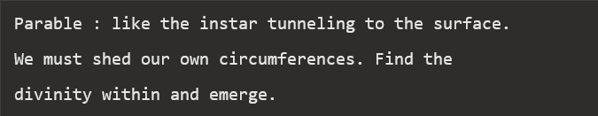

This is Parable 1,595,277,641 which [appeared in 2013](https://uncovering-cicada.fandom.com/wiki/Instar_emergence_(mp3_and_hidden_poem)#Meaning_of_Parable_1.2C595.2C277.2C641) within the ID tag of 761.mp3. The mp3 title is 'The Instar Emergence' which can be summed using the Gematria Primus to obtain '761'. The number 1,595,277,641 is similarly obtained using the product of the gematria sums of each line of the parable ie 1259*1031*1229 = 1,595,277,641.

Page 49, 50, 51

These pages contain the following ASCII text:

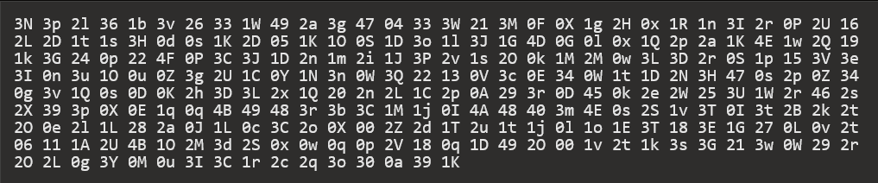

The first digit is always '0', '1', '2' or '3'. The last letter falls within '[0-9A-Za-x]', exactly 60 values. The maximum value is '4F'. This suggests a sexagesimal (base 60) counting system, where '4F' would correspond to '255'. The text can be rewritten in hexadecimal as follows:



The above does ignore the fact that there is also no 'f' letter in the text. Means that it could also be in base 59.

Page 49

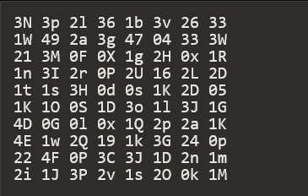

Page 50

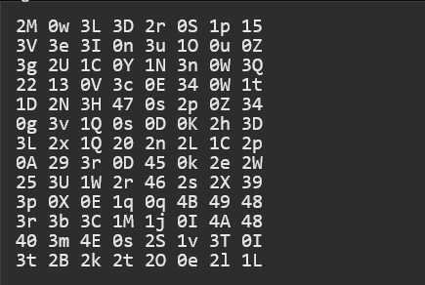

Page 51

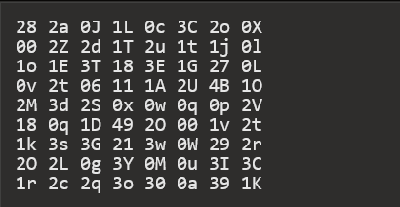

*Cicada in 2015*

In January 2015, to the dissapointment of some, nothing was heard from Cicada. No new puzzle appeared, only a dearth of terrible imitations and troll puzzles. Some theorized it was because the Liber Primus had not been completed, some believed the members they were looking for were enough, or even that 3301 had given up. Regardless of the individual opinions, there was only one public communication from 3301 in this year. Much like their [previous response to accusations of hacking](https://uncovering-cicada.fandom.com/wiki/3301_accused_of_cyberterrorism), 3301 responded similarily to a claim during the Planned Parenthood hack in july that the hacker involved was 3301

A New Post on Cicada's Twitter Account

[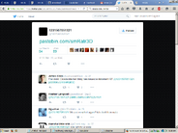](http://uncovering-cicada.wikia.com/wiki/File:Screenshot_2015-11-17_09.35.05.png)

At 10:35 P.M. on the 27th of July 2015, Cicada 3301 broke the silence and posted a Pastebin link to their official Twitter account, [@1231507051321:](https://twitter.com/1231507051321)

[10:35 PM - 27 Jul 2015 [Direct Link]](https://twitter.com/1231507051321/status/625902337266204673)

This tweet links to a [message from Cicada 3301 on Pastebin.](http://pastebin.com/smRatr3D)

**2015 "Planned Parenthood" Pastebin Message (Raw Text)**

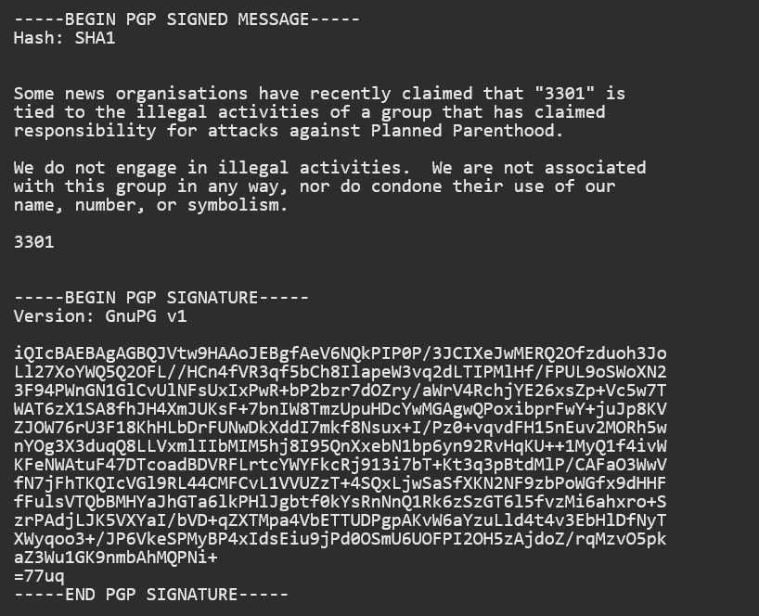

This message has a PGP signature; checking it against the Cicada 3301 PGP key proves that this message is in fact from Cicada 3301. Therefore, this is the first official message that Cicada 3301 has given us in 2015.

This message was posted shortly after a series of cyberattacks against Planned Parenthood were carried out by a group claiming to be Cicada 3301. This message refutes their claim, and states (once again) that Cicada 3301 is not involved in illegal activities. Soon after this message was released, the group admitted that they were not associated with Cicada 3301 in any way. This message is modified, but is directly copied from another message which Cicada 3301 released in 2012. There are, however, some unusual differences between the two that are worth mentioning.

[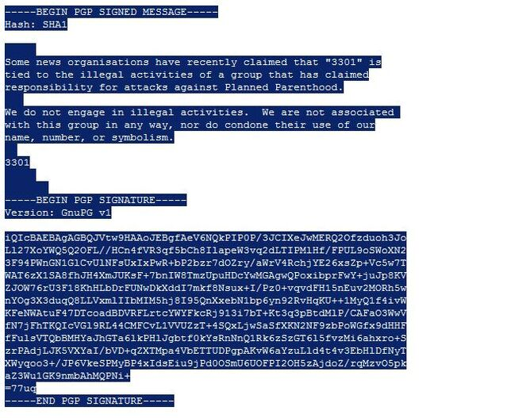](http://uncovering-cicada.wikia.com/wiki/File:Plannedp.jpg)

The 2015 "Planned Parenthood" message begins the same way, and uses very similar language. They again use the French "-ise" form for 'organization'. This time, however, 3301 refer to themselves simply as "3301", not "Cicada 3301." On the 7th line of this message, Cicada has omitted/forgotten a 'we': "...nor do [we] condone their use of our name..."

**Sequence of Numbered Spaces in "Planned Parenthood" Message:**

Interestingly, the lines are separated with more than just line breaks in this new message. There is a set of spaces between each paragraph, with a seemingly random number of space characters, before the line is broken and a new paragraph is started. On the line before the first paragraph is a set of 5 spaces. Between the first and second paragraph is a line with a set of 3 spaces. The second paragraph is followed by a line with a set of 2 spaces. The next line has has the signature "3301", followed by a line with a set of 5 spaces, and ending on a line with a set of 7 spaces. From the top down, this sequence spells out 5-3-2-5-7, or 53257. Individually, these digits are all prime. When you consider their placement in the message, the numbers 5-3-2 act as spacers between paragraphs, while 5-7 separates the "3301" signature from the end of the message. So you have the numbers 5-3-2 or 532, "3301", and 5-7 or 57. Remember that the rune pages were numbered 0-57, so this may be significant.

**The "message.txt.asc" File From 2014 Rune Pages**

Cicada used sets of spaces to represent numbers in a previous message as well, the [message.asc.txt](https://www.dropbox.com/sh/lkta4q921vliyuw/AABwIBrvR1AcQoTM3abMC3EPa/message.txt.asc?dl=0) file from the unfinished Rune Pages step in 2014 (that link goes to the original file, open it in a text editor like notepad). Most of their other messages and Pastebins are not separated with sets of spaces, but with ordinary line breaks (as in the "Necrome" message.) In the [message.txt.asc](http://pastebin.com/6M3s1FtC)the spaces were used to represent the prime sequence with an interesting omission. Here is a raw text version of message.txt.asc with the characters highlighted to show the sets of space characters:

[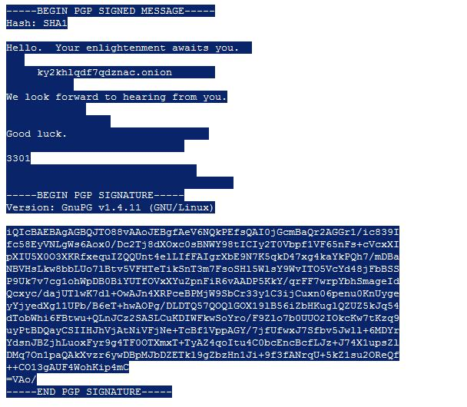](http://uncovering-cicada.wikia.com/wiki/File:Messagetxtasc.jpg)

Looking at the image above, we can see that Cicada 3301 used sets of spaces to separate and format this message. This is unnecessary, they could have simply used line breaks. The number of spaces used in each "set" follows the prime sequence, from top to bottom in the message. The number 19, however, is missing from this sequence and nobody could really figure out why it was omitted. Interestingly enough, if 19 were included in this sequence we would have a total of 12 primes. Without it we have 11, which is also a prime.

Below is a comparison of this message to the 2015 "Planned Parenthood" message, which shows these sequences in better detail.

"message.txt.asc" vs "Planned Parenthood" Message

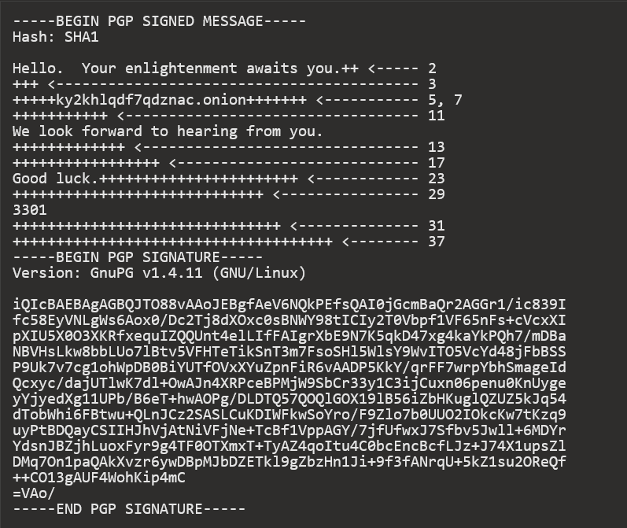

**"**Planned Parenthood" Message (Spaces Replaced and Counted):

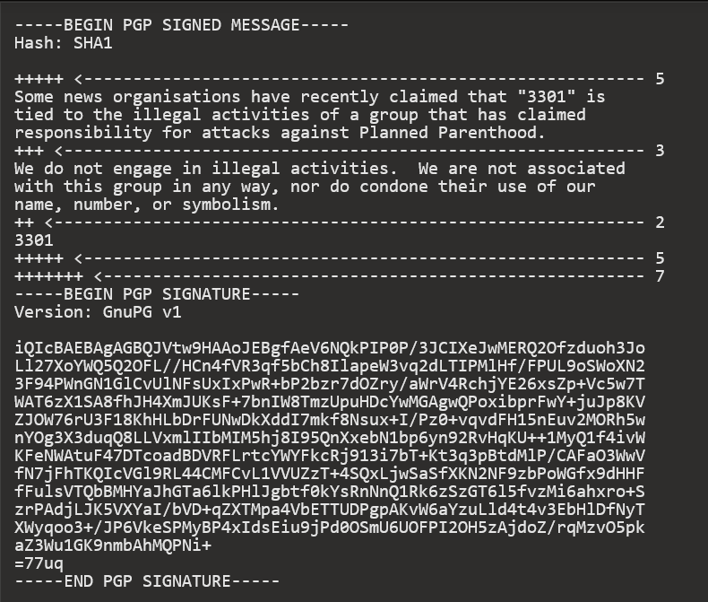

**Cicada in 2016**

Again in January of 2016, solvers found no new puzzle awaiting them at the start of January. This time, there was a message however. An image posted interestingly to Infotomb, a site that had been set up by a solver in previous years, originally to answer the question of how to send images while maintaining steganographic qualities of them.

The image, shown below, encouraged solvers not only to look back to the unfinished Liber Primus, but also to stop getting distracted by the imitations and fakes that always arise. This was during a time that a very large number of the new, inexperienced or even foolish users

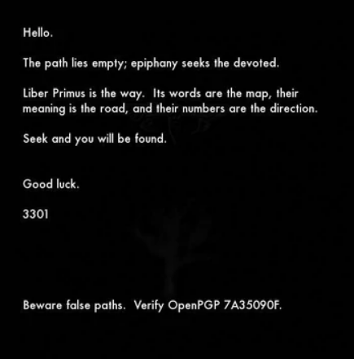

were following a long trail devoid of any sort of verifiable evidence of Cicada.

Cicada's Twitter Account: <https://twitter.com/1231507051321>

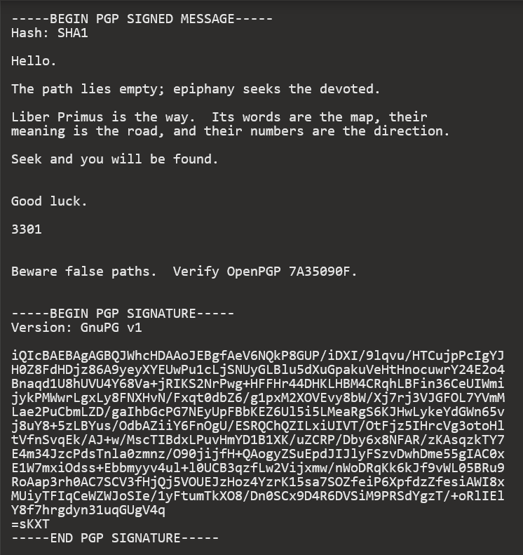

That's currently the end. The solvers have returned to their attempts on the Liber Primus, but it remains years since a page was decrypted.

PGP Signed Message April 2017

On April 29, 2017, a new user came to the [#cicadasolvers IRC channel](https://webchat.freenode.net/?channels=#cicadasolvers) and notified us that he found a new PGP signed message from 3301 on Pastebin. The user searched "7A35090F" - 3301's PGP key - on the site, sorted by date, and found a previously undiscovered message from 3301. Currently, this is the most recent communication from 3301, coming over a year after their last message. The message is a simple warning to stay on task and to check PGP. It demonstrates 3301 was still out there and looking for progress.

* <https://pastebin.com/yEiTHhvF>

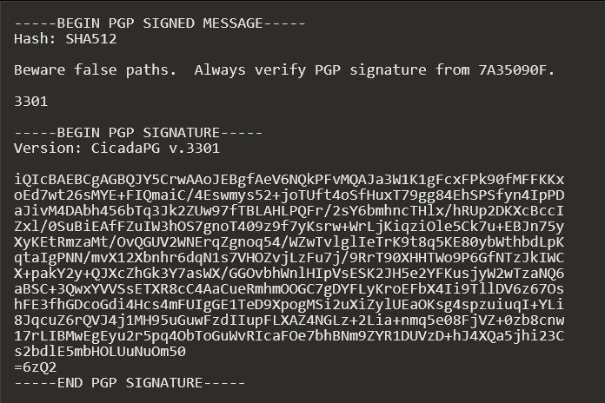

Message is signed with 0x7A35090F key. Date of signature is: *Signed on 2017-04-04 23:23*

[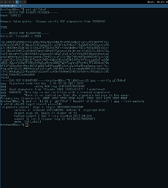](https://static.wikia.nocookie.net/uncovering-cicada/images/6/64/Discordisfornonces.png/revision/latest?cb=20200212143205)

More verifications:

* [prntscr](http://prntscr.com/f273a0),
* [imgur](https://i.imgur.com/1ma7Gwq.png),
* [cubeupload](https://u.cubeupload.com/Hk2qTm.jpg)

When #cicadasolvers users opened link, the Pastebin had 113 views. The user found the message 25 days after it was posted. According to google cache on April on 6 Apr 2017 11:46:25 GMT, the page had 72 views.

[prntscr.com](http://prntscr.com/f28ngf), [archive.fo](https://archive.fo/aD0JY), [webcache.google](https://webcache.googleusercontent.com/search?q=cache:https://pastebin.com/yEiTHhvF)

Here is how user found it:

**<psilynt1> I was looking for the last pgp encrypted message from cicada (you know**

**the old one linked from twitter that said to verify with pgp)**

**<psilynt1> searched for**

**<psilynt1> searched for '7A35090F' on pastebin, sorted by date and there it was...**

**I thought it was the same, validated it, realized that WASN'T the same, realized**

**the pastebin date and brotherbin caught me posting it in a discord.**

**<psilynt1> I posted it in discord, here, then in defango's youtube chat.**

# Liber Primus

[*17 already solved pages*](https://uncovering-cicada.fandom.com/wiki/Liber_Primus)

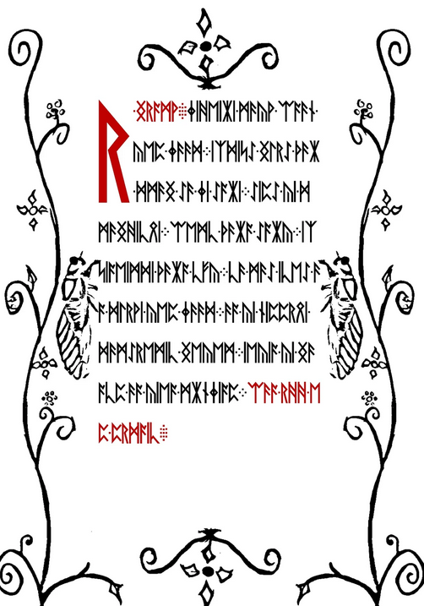

A WARNING  
BELIEVE NOTHING FROM THIS BOOK  
EXCEPT WHAT YOU KNOW TO BE TRUE  
TEST THE KNOWLEDGE  
FIND YOUR TRUTH  
EXPERIENCE YOUR DEATH  
DO NOT EDIT OR CHANGE THIS BOOK  
OR THE MESSAGE CONTAINED WITHIN  
EITHER THE WORDS OR THEIR NUMBERS  
FOR ALL IS SACRED

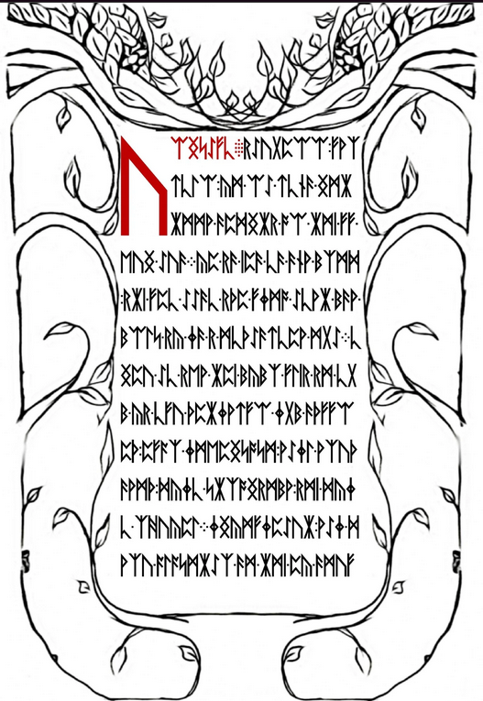

WELCOME

WELCOME, PILGRIM, TO THE GREAT JOURNEY TOWARD THE END OF ALL THINGS

IT IS NOT AN EASY TRIP, BUT FOR THOSE WHO FIND THEIR WAY HERE IT IS A NECESSARY ONE

ALONG THE WAY YOU WILL FIND AN END TO ALL STRUGGLE AND SUFFERING, YOUR INNOCENCE, YOUR ILLUSIONS, YOUR CERTAINTY, AND YOUR REALITY

ULTIMATELY, YOU WILL DISCOVER AN END TO SELF

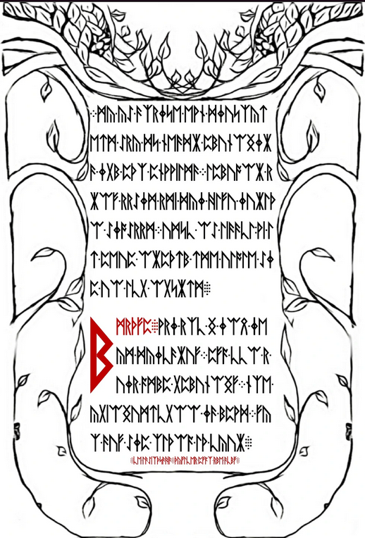

IT IS THROUGH THIS PILGRIMAGE THAT WE SHAPE OURSELVES AND OUR REALITIES

JOURNEY DEEP WITHIN AND YOU WILL ARRIVE OUTSIDE

LIKE THE INSTAR, IT IS ONLY THROUGH GOING WITHIN THAT WE MAY EMERGE

WISDOM

YOU ARE A BEING UNTO YOURSELF

YOU ARE A LAW UNTO YOURSELF

EACH INTELLIGENCE IS HOLY

FOR ALL THAT LIVES IS HOLY

AN INSTRUCTION COMMAND YOUR OWN SELF

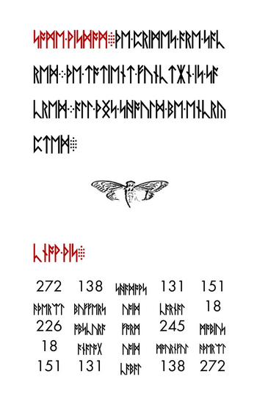

SOME WISDOM

THE PRIMES ARE SACRED

THE TOTIENT FUNCTION IS SACRED

ALL THINGS SHOULD BE ENCRYPTED

KNOW THIS

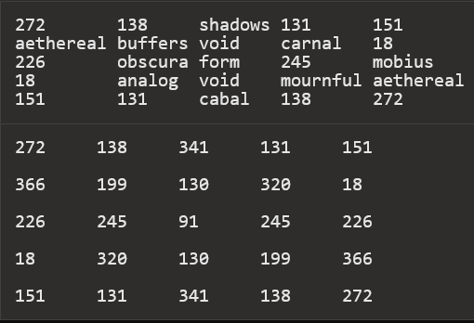

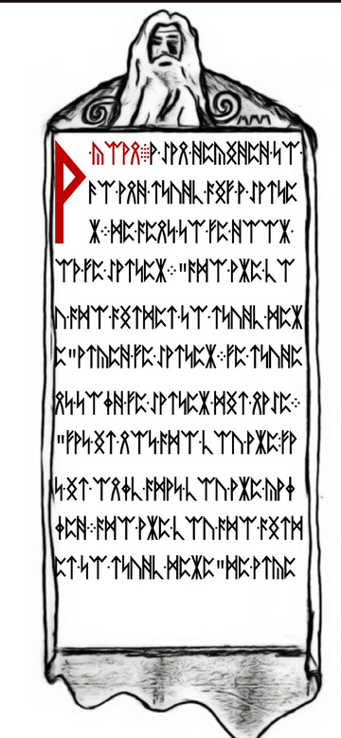

A KOAN

A MAN DECIDED TO GO AND STUDY WITH A MASTER

HE WENT TO THE DOOR OF THE MASTER

"WHO ARE YOU WHO WISHES TO STUDY HERE" ASKED THE MASTER

THE STUDENT TOLD THE MASTER HIS NAME

"THAT IS NOT WHO YOU ARE, THAT IS ONLY WHAT YOU ARE CALLED

WHO ARE YOU WHO WISHES TO STUDY HERE" HE ASKE



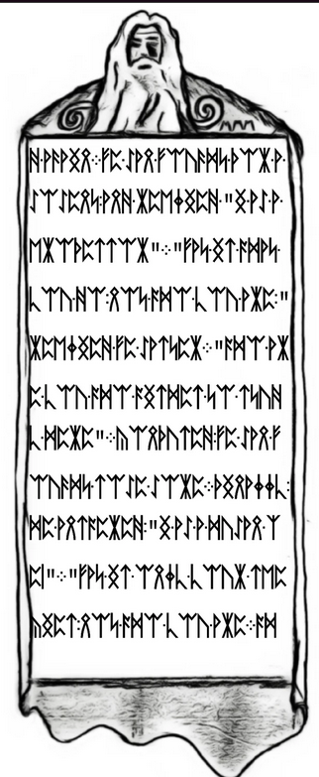

D AGAIN

THE MAN THOUGHT FOR A MOMENT, AND REPLIED "I AM A PROFESSOR"

"THAT IS WHAT YOU DO, NOT WHO YOU ARE," REPLIED THE MASTER

"WHO ARE YOU WHO WISHES TO STUDY HERE"

CONFUSED, THE MAN THOUGHT SOME MORE

FINALLY, HE ANSWERED, "I AM A HUMAN BEING"

"THAT IS ONLY YOUR SPECIES, NOT WHO YOU ARE

WH

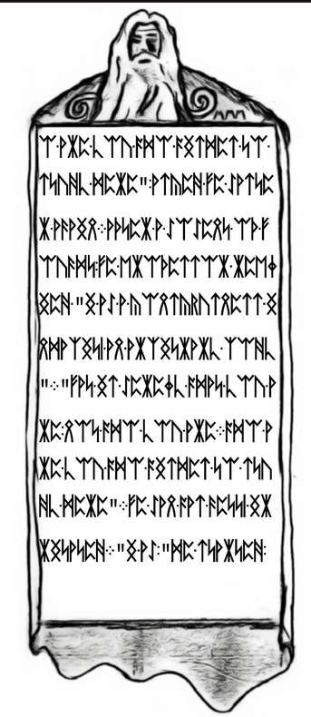

O ARE YOU WHO WISHES TO STUDY HERE", ASKED THE MASTER AGAIN

AFTER A MOMENT OF THOUGHT, THE PROFESSOR REPLIED "I AM A CONSCIOUSNESS INHABITING AN ARBITRARY BODY"

"THAT IS MERELY WHAT YOU ARE, NOT WHO YOU ARE

WHO ARE YOU WHO WISHES TO STUDY HERE"

THE MAN WAS GETTING IRRITATED

"I AM," HE STARTED,

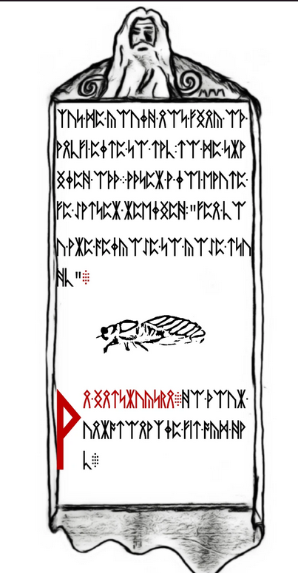

BUT HE COULD NOT THINK OF ANYTHING ELSE TO SAY, SO HE TRAILED OFF

AFTER A LONG PAUSE THE MASTER REPLIED, "THEN YOU ARE WELCOME TO COME STUDY"

AN INSTRUCTION

DO FOUR UNREASONABLE THINGS EACH DAY

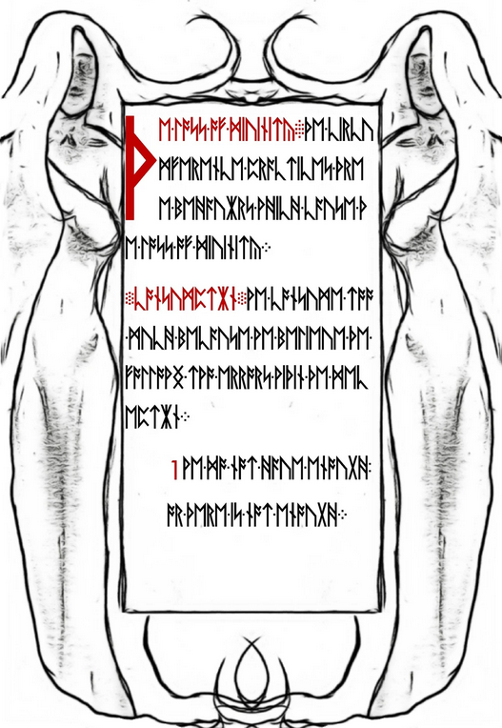

THE LOSS OF DIVINITY

THE CIRCUMFERENCE PRACTICES THREE BEHAVIORS WHICH CAUSE THE LOSS OF DIVINITY

CONSUMPTION

WE CONSUME TOO MUCH BECAUSE WE BELIEVE THE FOLLOWING TWO ERRORS WITHIN THE DECEPTION

1 WE DO NOT HAVE ENOUGH, OR THERE IS NOT ENOUGH

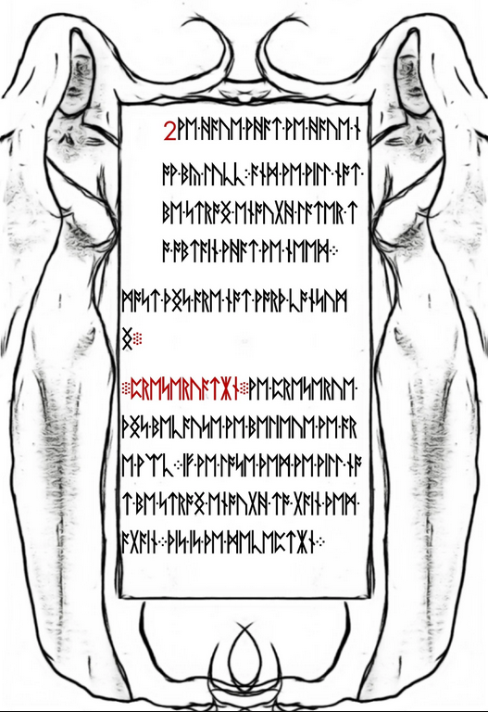

2 WE HAVE WHAT WE HAVE NOW BY LUCK; AND WE WILL NOT BE STRONG ENOUGH LATER TO OBTAIN WHAT WE NEED

MOST THINGS ARE NOT WORTH CONSUMING

PRESERVATION

WE PRESERVE THINGS BECAUSE WE BELIEVE WE ARE WEAK

IF WE LOSE THEM WE WILL NOT BE STRONG ENOUGH TO GAIN THEM AGAIN

THIS IS THE DECEPTION

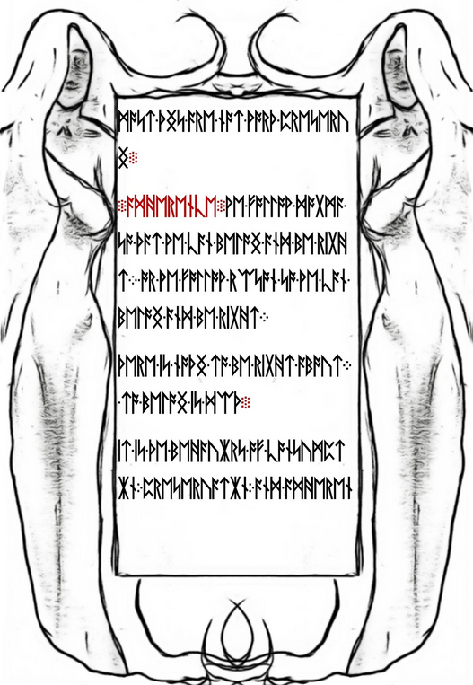

MOST THINGS ARE NOT WORTH PRESERVING

ADHERENCE

WE FOLLOW DOGMA SO THAT WE CAN BELONG AND BE RIGHT; OR WE FOLLOW REASON SO WE CAN BELONG AND BE RIGHT

THERE IS NOTHING TO BE RIGHT ABOUT; TO BELONG IS DEATH

IT IS THE BEHAVIORS OF CONSUMPTION, PRESERVATION, AND ADHEREN

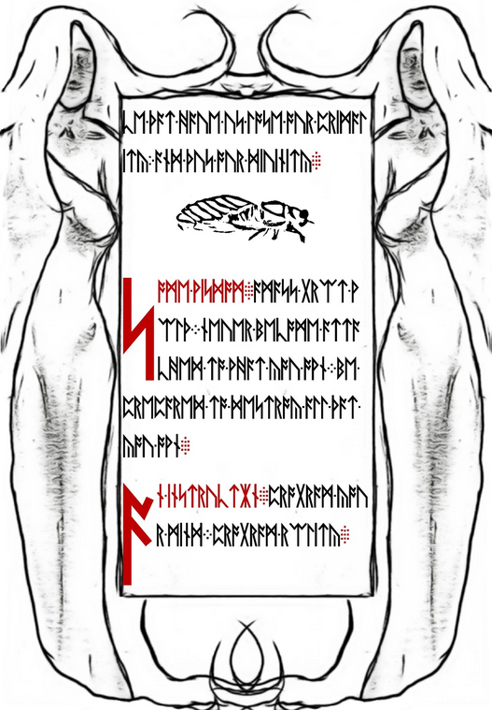

CE THAT HAVE US LOSE OUR PRIMALITY, AND THUS OUR DIVINITY

SOME WISDOM

AMASS GREAT WEALTH

NEVER BECOME ATTACHED TO WHAT YOU OWN

BE PREPARED TO DESTROY ALL THAT YOU OWN

AN INSTRUCTION

PROGRAM YOUR MIND

PROGRAM REALITY

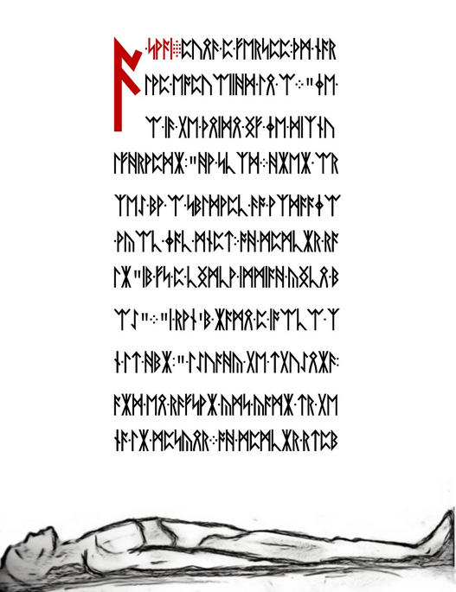

A KOAN

DURING A LESSON, THE MASTER EXPLAINED THE I

"THE I IS THE VOICE OF THE CIRCUMFERENCE," HE SAID

WHEN ASKED BY A STUDENT TO EXPLAIN WHAT THAT MEANT; THE MASTER SAID "IT IS A VOICE INSIDE YOUR HEAD"

"I DON'T HAVE A VOICE IN MY HEAD," THOUGHT THE STUDENT, AND HE RAISED HIS HAND TO TELL THE MASTER

THE MASTER STOP

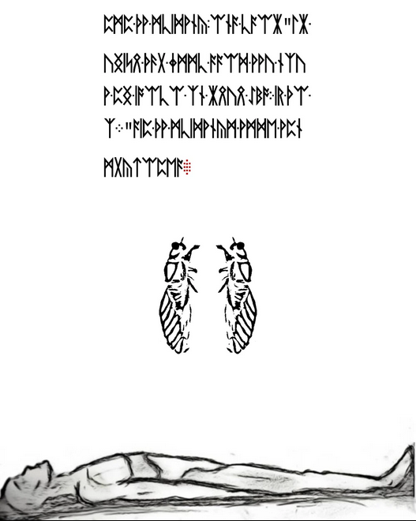

PED THE STUDENT, AND SAID "THE VOICE THAT JUST SAID YOU HAVE NO VOICE IN YOUR HEAD; IS THE I"

AND THE STUDENTS WERE ENLIGHTENED

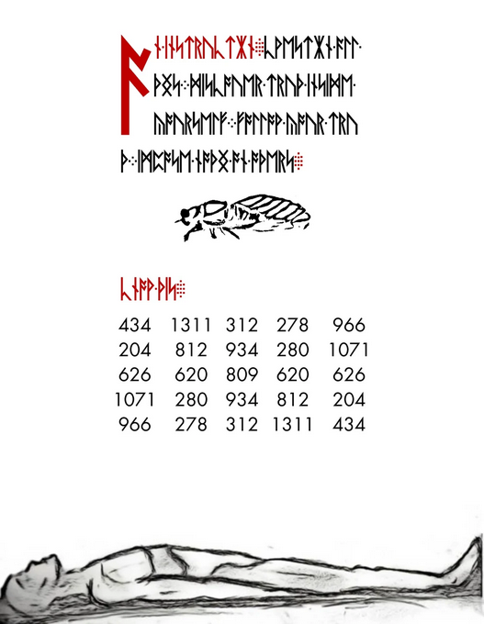

AN INSTRUCTION

KWESTION ALL THINGS DISCOVER TRUTH INSIDE YOURSELF FOLLOW YOUR TRUTH IMPOSE NOTHING ON OTHERS

KNOW THIS

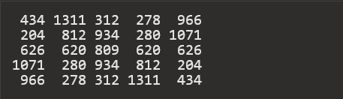

# Liber Primus Unsolved Pages

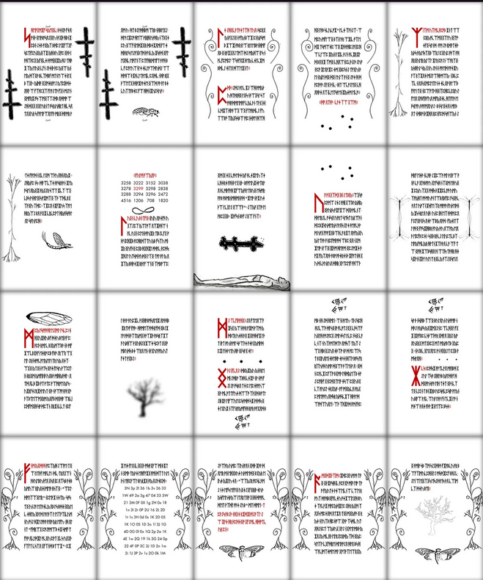

REFERENCES

<https://www.fastcompany.com/3025785/meet-the-man-who-solved-the-mysterious-cicada-3301-puzzle>

<https://uncovering-cicada.fandom.com/wiki/What_Happened_Part_1_(2013)>

<https://www.bbc.com/news/technology-25667292>

<https://www.telegraph.co.uk/technology/internet/10468112/The-internet-mystery-that-has-the-world-baffled.html?fb>

<https://uncovering-cicada.fandom.com/wiki/Uncovering_Cicada_Wiki>

<https://en.wikipedia.org/wiki/Cicada_3301>

<https://cloudfreak.medium.com/cicada-3301-the-internet-mystery-d61367c4ad77>

<https://www.wnycstudios.org/podcasts/notetoself/articles/meet-teenage-codebreaker-who-helped-solve-cicada-3301-internet-puzzle>

<https://medium.com/great-big-story/series-premiere-cicada-3301-81d8b80f542e>

<https://www.boxentriq.com/code-breaking/cicada-3301-first-puzzle-walkthrough>

<https://documents2.theblackvault.com/documents/nsa/85764B.pdf>

<https://www.businessinsider.in/tech/after-over-a-year-of-silence-a-mysterious-online-puzzle-has-returned-with-a-cryptic-tweet/articleshow/50570110.cms>

<https://www.cicadasolvers.com/documentary/>

<https://uncovering-cicada.fandom.com/wiki/Liber_Primus>

<file:///C:/Users/725go/Downloads/instapdf.in-liber-primus-499.pdf>

<https://therealsamizdat.com/2019/09/12/cicada-files-schoenberger-1/>